Bulgarian Chemical Communications, Volume 50, Issue 1, (pp. 172 – 176) 2018

Experimental study on the feasibility of reducing coal dust by alkaline solution

H. Y. Guo1, 2, 3, Zh. X. Gao1, Ch. Y. Fu1, Y. Luo1, D. P. Xia1, 3 *
1 State and Local Joint Engineering Laboratory for Gas Drainage & Ground Control of Deep Mines (Henan Polytechnic University), Jiaozuo 454000, China
2 State Key Laboratory Cultivation Base for Gas Geology and Gas Control (Henan Polytechnic University), Jiaozuo 454000, China
3 Collaborative Innovation Center of Coalbed Methane and Shale Gas for Central Plains Economic Region, Jiaozuo 454000, China
Received February xx, 2017; Revised April xx, 2017
In order to investigate the feasibility of reducing coal dust by alkaline solution, three representative samples of bituminous D, bituminous C and bituminous B coal with different metamorphic degrees were collected and soaked in
0.2 mol/L、0.5 mol/L、1.0 mol/L NaOH, respectively, for 5 days. The variation characteristics of coal wettability index were analyzed by the ways of contact angle, pulverized coal subsidence, reverse permeation and scanning electron microscopy (SEM). The results showed that the contact angle of coal samples after soaking in the alkaline solution decreased, the reverse permeation effect obviously increased, and the sedimentation effect of pulverized coal also increased. At the same time, the coal wettability index tended to increase with the decrease of metamorphic degree of the coal and the increase of NaOH concentration. After the samples were soaked in alkaline solution, the pores and fissures, and the roughness of the coal surface significantly increased, and the change trend was consistent with wettability, which indicated that the contact of alkaline solution with the coal structure was the main reason for the enhancement of coal wettability. The study provided experimental support for application of alkaline solution in coal mine dust removal, and had potential application foreground.
Keywords: Alkaline solution; Coal dust; Wettability; Contact angle; Reverse permeation; Microstructure

INTRODUCTION
Coal dust is one of the main disaster sources in coal mines; it not only causes pneumoconiosis of miners, reduces the service life of equipment, but also causes serious casualties such as coal dust explosions. The traditional methods of dedusting mainly rely on coal seam water infusion and water mist spraying, but the coal dust is not easy to be quickly wetted and agglomerated by water because of its hydrophobicity and the large surface tension of water [1]. The coal mines have achieved a certain effect in dust removal by adding sodium salts, surfactants and other agents to reduce the surface tension of water [2-6]. However, the over-standard concentration of dust is still a serious security problem in coal production because the coal seam water infusion is difficult and coal water content rate does not reach the standard.
There is a significant amount of organic matter in low-rank coals, which can react with alkaline solution to significantly change the physicochemical structure [7,8]. In addition, low-rank coals are rich in various organic

*) To whom all correspondence should be sent: E-mail: 569689819@qq.com
components and minerals, and some scholars have found that sulfurous functional groups and minerals in coal are easy to react with alkaline solution, which is mainly used in coal chemical industry for deashing, desulfurization and catalysis [9-12]. Recently, researchers have found that alkaline solution can significantly reduce the mechanical strength of coal, which is beneficial to the prevention of rock burst [13,14] and H₂S disasters in mines [15]. Besides, alkaline solution can improve the pore structure of the coal reservoir and is beneficial to the seepage and extraction of gas [16-17]. However, the research of alkaline solution for the control of coal dust has not received enough attention. In order to explore the feasibility of coal dust treatment with alkaline solution, various indices of coal wettability such as contact angle, pulverized coal sedimentation, reverse permeation and microstructures were analyzed in this paper to provide a reference for the extended application of alkaline solution in coal mine dust removal.
SAMPLE COLLECTION AND ANALYSIS
Fresh coal samples were collected from the coal face of the Qianqiu mine in Yima, Henan, the

172
© 2018 Bulgarian Academy of Sciences, Union of Chemists in Bulgaria

H.Y. Guo et al.: Experimental study on the feasibility of reducing coal dust by alkaline solution

Yongdingzhuang mine in Datong, Shanxi, and the Shaqu mine in Liulin, Shanxi respectively. The
Table 1 Coal sample information
industrial components and the vitrinite reflectance were analyzed (Table 1).

Sample source | Horizon | Times | V_{daf}% | M_{ad}% | A_{ad}% | Coal rank | Ro,max%
Qianqiu mine | 2-3 | J₂y | 40.01 | 0.98 | 10.31 | Bituminous D | 0.56
Yongdingzhuang mine | 14# | J₂d | 32.15 | 2.33 | 3.33 | Bituminous C | 0.74
Shaqu mine | 4# | P₁sh | 22.31 | 2.09 | 8.32 | Bituminous B | 1.51

EXPERIMENTAL RESULTS AND DISCUSSION
Contact angle experiment
The bituminous D, bituminous C and bituminous B coal samples were dried and pulverized into 200 mesh, and each coal sample was divided into four parts. One of the four parts was the raw coal sample and was numbered D0, C0, B0, respectively; the others were soaked in 0.2 mol/L, 0.5 mol/L and 1 mol/L NaOH for 5 days, numbered D1, C1,
Table 2. Test results of contact angle (/°)
B1；D2, C2, B2；D3, C3, B3, respectively. Then the coal samples were cleaned, centrifuged, and dried, respectively, together with the raw coal sample. Then the pulverized coal was made into a round calendaring plane test piece with a mean thickness of 1 mm. The contact angle between each test piece and water was measured by JC2000B2 three times in different positions. The averages are shown in Table 2.

Bituminous D |  | Bituminous C |  | Bituminous B
Sample  number | Contact  angle | Sample  number | Contact  angle | Sample  number | Contact  angle
D0 | 106.5 | C0 | 109.5 | B0 | 97.5
D1 | 62.5 | C1 | 105 | B1 | 93.5
D2 | 47 | C2 | 81 | B2 | 74.5
D3 | 41 | C3 | 63 | B3 | 63.5

The contact angles between the raw coal samples and water were more than 90°, as seen in Table 2, showing strong hydrophobicity and poor wettability. However, the contact angles sharply decreased after soaking the samples in alkaline solution, which indicated that the hydrophilicity and the wettability of the coal samples increased. With the increase in alkaline solution concentration, the contact angle decreased in a different degree. Especially the change of contact angle of bituminous D belonging to low-rank coal is most obvious, the contact angle decreased from 106.5°to 41°, and the decrease amplitude was more than 60%; the contact angle of bituminous C decreased from 109.5°to 63°, and the decrease amplitude was more than 40%; the contact angle of bituminous B decreased from 97.5°to 63.5°, and the decrease amplitude was more than 30%. The results showed that the contact angle gradually decreased with the increase in coal metamorphism.
Sedimentation experiment of pulverized coal
After soaking the pulverized coal in different concentrations of alkaline solution for 5 days , the samples were dried, the sedimentation experiment was carried out together with the raw coal (Figure 2). The sedimentation effect becomes worse with
the increase in coal metamorphism: the sedimentation effect of bituminous D is the best, followed by bituminous C and bituminous B. The sedimentation effect of coal samples soaked in different concentrations of alkaline solution follows the rule 0.2 mol/L < 0.5mol/L < 1 mol/L and the raw coal has basically no sedimentation. At the sedimentation time of 15~30 min, all bituminous B samples displayed no changes in sedimentation, while bituminous D and bituminous C after alkaline solution treatment have sedimented and the raw coal (bituminous D, bituminous C) little changed.
Reverse permeation experiment of pulverized coal
The experimental device of the reverse permeation is shown in Figure 3. The pulverized coal of 1 g was put into a glass tube with an inner diameter of 5.5 mm, height of 10 cm and tap of which the bottom end was sealed with permeable rubberized fabric and put it into water. When the liquid height in the glass tube no longer raised, the glass tube was taken out to calculate the weight of the pulverized coal. Each sample was measured 3 times. The averages are shown in Table 3 and Figure 4. As seen in Figure 4, the water absorption of the raw coal is relatively poor. However, the water absorption significantly increased after NaOH

H.Y. Guo et al.: Experimental study on the feasibility of reducing coal dust by alkaline solution
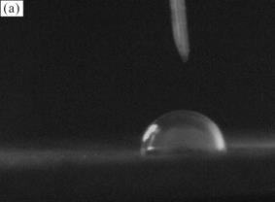
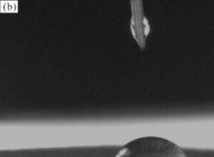
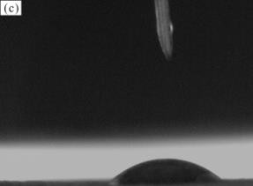
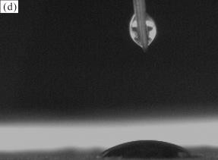
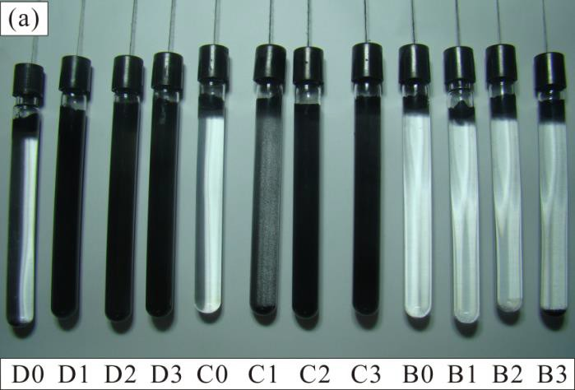
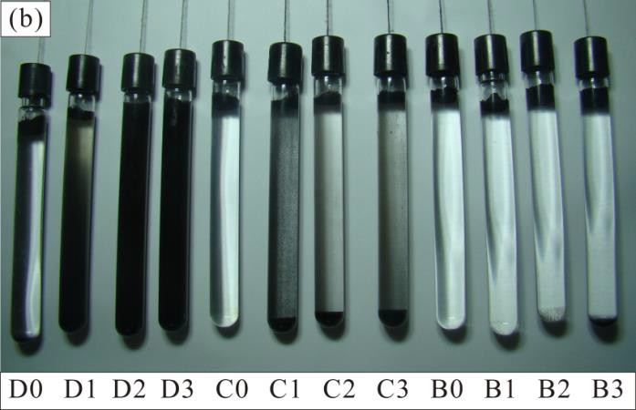
treatment. As the concentration of alkaline solution increased, the water absorption gradually increased, but the change range was relatively small when the concentration of alkaline solution was between 0.5 mol/L and 1 mol/L.

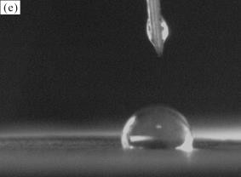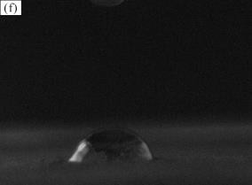

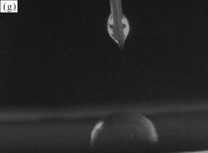
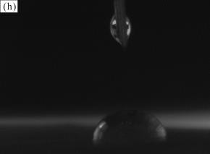
Fig. 2. Sedimentation changes of coal samples soaked in alkaline solution over time (a) 15 min; (b) 45 min.

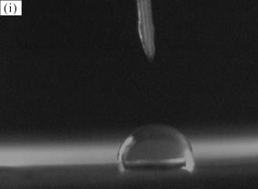
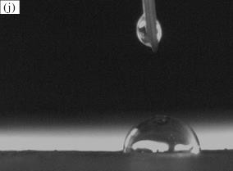
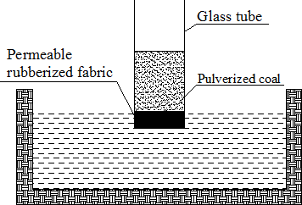

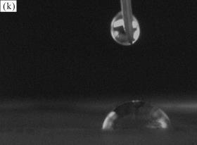
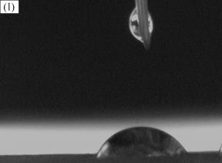
Fig. 3. Experimental device of the reverse permeation.

Fig.1. Changes of contact angle of coal soaked in NaOH solutions of different concentrations ((a, e, i) represent D0, C0, B0; (b, f, j) represent D1, C1, B1; (c, g,
k) represent D2, C2, B2; (d, h, l) represent D3, C3, B3; respectively).
Table 3. Water absorption of the raw coal and the coal samples soaked in alkaline solution/g.
Sample  number | Water  absorption | Sample  number | Water  absorption | Sample  number | Water  absorption
D0 | 0.0128 | C0 | 0.0045 | B0 | 0.0022
D1 | 0.5041 | C1 | 0.1421 | B1 | 0.1855
D2 | 0.6786 | C2 | 0.2174 | B2 | 0.2844
D3 | 0.6796 | C3 | 0.2584 | B3 | 0.3527

H.Y. Guo et al.: Experimental study on the feasibility of reducing coal dust by alkaline solution
0.7
0.6
0.5
0.4
0.3
0.2
0.1
0.0

(a)
0.7
0.6
0.5
0.4
0.3
0.2
0.1
0.0
Water sbsorption/g

(b)

(c)

0.7
0.6
0.5
0.4
0.3
0.2
0.1
0.0

The raw coal 0.2mol/LNaOH 0.5mol/LNaOH 1.0mol/LNaOH
Water absorption/g
Water absorption/g
Bituminous D
The raw coal
0.2mol/LNaOH 0.5mol/LNaOH 1.0mol/LNaOH
Bituminous C
The raw coal
  - mol/LNaOH 0.5mol/LNaOH 1.0mol/LNaOH
Bituminous B

Fig.4. Comparison of water absorption of the raw coal and the coal samples soaked in alkaline solution (a) Bituminous D; (b) Bituminous C; (c) Bituminous C.
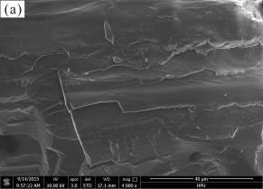
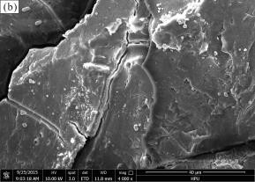
Compared with bituminous C and bituminous B samples, the metamorphic degree of bituminous D is lower, and the water absorption effect is the most obvious after NaOH treatment, while the change range of the medium-rank coal (bituminous C, bituminous B) is far less than of bituminous D.
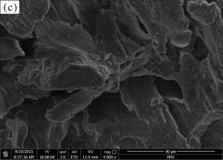
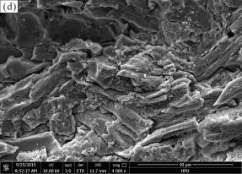
Experiment of alkaline solution on the surface structure of coal
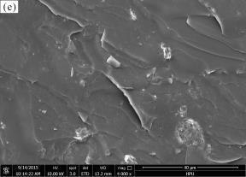
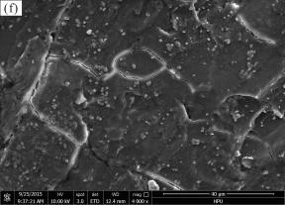
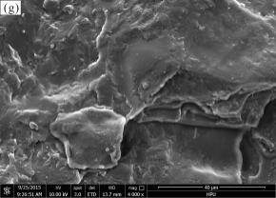
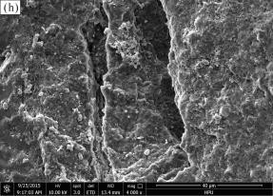
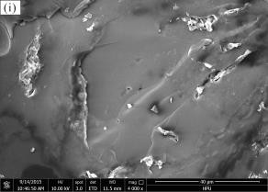
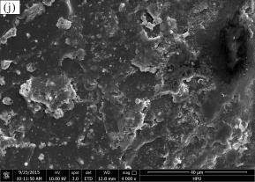
Small pieces of bituminous D, bituminous C and bituminous B coal were prepared and soaked in 0.2 mol/L, 0.5 mol/L, 1.0 mol/L NaOH solution for 5 days, respectively. Then the treated coal and raw coal samples were dried in oven and were placed into the 108 Auto Cressington Sputter Coater to pump vacuum, plat with gold, and then were observed by Quanta 250 environmental scanning elecrron microscope (Figure 5). By comparing the micro-morphology of the coal samples before and after treatment with the alkaline solution (Figure 5), we found that the surface of the raw coal was flat and smooth. However, the surface of the coal sample appeared more microporous and the roughness increased markedly after soaking in the alkaline solution. The effect of alkaline solution on coal samples gradually weakened when the metamorphic degree of coal increased. The surface of bituminous D was seriously etched after soaking in 1 mol/l NaOH, while the change degree of bituminous B was relatively small. When the concentration of alkaline solution decreased, the etching on coal surface gradually decreased.
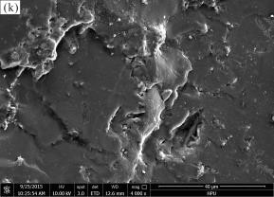
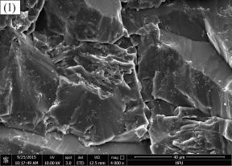
CONCLUSIONS
The results of contact angle, pulverized coal sedimentation, and reverse permeation experiments showed that the wettability of raw coal is poor, but significantly increased after NaOH treatment. The

wetting effect gradually weakened when the metamorphic degree of coal increased, but the wettability correspondingly increased when the concentration of alkaline solution increased, and the change range was stable.
Fig.5. Variation characteristics of the surface structure of the coal samples before and after treatment with the alkaline solution ((a, e, i) represent D0, C0, B0; (b, f, j) represent D1, C1, B1; (c, g, k) represent D2, C2, B2; (d, h, l) represent D3, C3, B3; respectively).
The microstructure observation proved that the surface porosity and roughness significantly

H.Y. Guo et al.: Experimental study on the feasibility of reducing coal dust by alkaline solution

increased after NaOH treatment, and the change trend was basically identical with that of the results of wettability experiments, which means that the change of coal structure caused by alkaline solution was the internal factor of wettability improvement. Besides the effect on bump proneness of coal, permeability and H₂S disaster, the alkaline solution can effectively improve wettability of pulverized coal and has a significant engineering value on the reduction of coal dust.
Acknowledgements: This study was funded by the National Science Foundation of China (Grant no. 41472127, 41472129 and 41502158), Program for Innovative Research Team in University of Ministry of Education of China (IRT_16R22), Shanxi Provincial Program for Tackling Key Problems of Coal-based Science and Technology (Grant no. MQ2014-01), Shanxi Province Joint Research Fund of Coalbed Methane (Grant no. 2013012004), and Scientific and Technological Research Projects of Henan Province (Grant no. 172102310717). The authors are grateful to the editor and anonymous reviewers of this paper.
REFERENCES
    - Zh.B. Zhao, C. Yang, Ch.Y. Sun, X.Q. Shu, J. China Coal Soc., 36, 442 (2011).
    - Q.G. Yao, C.C. Xu, Y.S. Zhang, D. Wang, Process Safety&Environ. Protection, 111, 726 (2017).
    - J.L. Li, F.B. Zhou, H. Liu, Int. J. Coal Prepar. Utiliz.,
36, 192 (2015).
    - J. Yang, Y.Zh. Tan, Zh.H. Wang, Y.D. Shang, W.B. Zhao, J. China Coal Soc,, 32, 737 (2007).
    - K.S. Zeng, N.L Hu, W.M. Cheng, G. Zhou, P. Yang,
J. China Coal Soc., 34, 1675 (2009).
    - Z. Xi, M. Jiang, J. Yang, X. Tu, Process Safety&Environ. Protection, 92, 637 (2014).
    - S. Erdogan, M. Zahir Duz, M. Merdivan, C. Hamamci, Energy Sources, 27, 423 (2005).
    - C. Xu, S.S. Yu, X.S. Cong, J.S. Ma, N. Nie, J.X. Chen, J. Shenyang Univ. Chem. Technol., 25, 35 (2011).
    - J. Xiao, F.Ch. Li, S.Y. Deng, Q.F. Zhong, Y.Q. Lai, J. Li, J. Central South Univ. (Science and Technology), 47, 14 (2016).
    - N. Mketo, P. N. Nomngongo, J. C. Ngila, Environ. Sci. Pollution Res. Int., 24, 19852 (2017).
    - B. Baatar, T. Ganerdene, M. Myekhlai, U. Otgonbayar, C. Majaa, Y. Turmunkh, N, Javkhlantugs, Energy Sources, Part A, Recovery, Utilization & Environmental Effects, 39, 1 (2017).
    - P. S. Dash, S. S. Kumar, P. K. Banerjee, S. Ganguly, Mineral Process. Extract. Metallurgy Review, 34, 223 (2013).
    - H.Y Guo, X.B. Su, D.P. Xia, J.Q. Ma, Sh. B. Zhang, X. Liu, J.X. Song, H.X. Lin, ZL 201310010316.4.
    - D.P Xia, H.Y. Guo, Y. Luo, J.Q. Ma, Sh.L. Chen, Zh. Wang, J. China Coal Soc., 40, 1768 (2015).
    - K.X. Wang, X.H. Fu, Coal Sci. Technol., 35, 94 (2007).
    - L.L. Song, L. Feng, J.T. Liu, Y. Zhang, X.H. Wang, Zh.Y. Miao, J. China University of Mining & Technology, 41, 629 (2012).
    - C.X. Hou, Sh. Zhang, Y.H. Liang, J.W. Du, L.H. Fan,
Coal Conversion, 39, 19 (2016).

ЕКСПЕРИМЕНТАЛНО ИЗСЛЕДВАНЕ НА ВЪЗМОЖНОСТИТЕ ЗА НАМАЛЯВАНЕ НА ВЪГЛИЩНИЯ ПРАХ С ПОМОЩТА НА АЛКАЛЕН РАЗТВОР
Х. Гуо1, 2, 3, Ж. Гао1, Ч. Фу1, И. Луо1, Д. Ксиа1, 3 *
1 Държавна и местна инженерна лаборатория за дрениране на газ и контрол на терена на дълбоки мини (Политехнически университет на Хенан), Джаозуо 454000, Китай
2 Държавна лаборатория и и култивационна база за газова геология и газов контрол (Политехнически университет на Хенан), Джаозуо 454000, Китай
3 Съвместен иновационен център по въглищен метан и шистов газ за икономическата област на Централните равнини, Джаозуо 454000, Китай
Постъпила на хх февруари, 2017 г.; Коригирана на хх април, 2017 г. (Резюме)
За изследване на възможностите за намаляване на въглищния прах в мини с помощта на алкален разтвор са взети три представителни проби от битуминозни D, битуминозни С, и битуминозни В въглища с различна степен на метаморфоза и са държани съответно в 0.2 mol/L, 0.5 mol/L и 1.0 mol/L NaOH в продължение на 5 дни. Промяната на умокряемостта на въглищата е проследена чрез измерване на контактния ъгъл, седиментацията на прахообразните въглища, обратната пропускливост и SEM. Установено е, че контактният ъгъл на въглищните проби намалява след престоя в алкален разтвор, ь обратната пропускливост и утаяването на прахообразните въглища нарастват. Същевременно, индексът на умокряне на въглищата клони към намаляване при понижаване на степента на метаморфоза и повишаване на концентрацията на NaOH. След престой в алкален разтвор порите и цепнатините, както и грапавостта на въглищната повърхност значително се увеличават и тази тенденция е в съгласие с умокряемостта. Това показва, че контактът на алкалния разтвор с въглищната структура е основната причина за повишаване на умокряемостта. Изследването дава експериментално потвърждение за приложението на алкален разтвор за отстраняване на въглищен прах.

