Using UV/ZnO process for degradation of Acid red 283 in synthetic wastewater
A. Shokri¹*, K. Mahanpoor²
¹ Young Researchers and Elite Club, Arak Branch, Islamic Azad University, Arak, Iran
² Department of Chemistry, Faculty of Science, Arak Branch, Islamic Azad University, Arak, Iran.
Received February 28, 2017; Accepted December 23, 2017
In this research, the photocatalytic degradation of Acid red 283 (AR283) was investigated by the UV/ZnO process in a batch photoreactor. The experiments revealed that the ZnO nanocatalyst and UV light had a slight influence when they were used separately. The impact of various factors such as initial pH, initial dosage of dye and catalyst on the degradation efficiency was investigated. The degradation and mineralization of AR 283 were estimated by HPLC and COD tests, respectively. At optimum conditions (0.3 g/L of catalyst, pH 8 and initial concentration of AR283 25 mg/l), the removal of AR283 and COD were 99.5 and 58.5% at 60 and 120 min of reaction, respectively. The pseudo-first-order kinetics of the removal of AR283 can be explained in terms of the Langmuir–Hinshelwood model. The apparent rate constant ($k_{app}$ =27.2$×{10}^{-3}\min^{-1}$) was obtained.
Keywords: UV/ZnO process, Mineralization, Langmuir-Hinshelwood, Batch photoreactor, Acid red 283.

INTRODUCTION
The chemical industries produce wastewater containing non-biodegradable and toxic compounds that remain in the environment even after conventional treatment processes [1]. Large quantities of dyes are annually created and applied in different industries such as textile, paper, cosmetic, leather, nutrition and pharmaceutical industries [2]. The presence of even trace concentrations of dyes in the waste is highly visible and unpleasant. It can cause some severe problems to aquatic life and human health [3]. The discharge of the wastes from the textile industries contains noxious chemicals such as azo and reactive dyes which affect the natural resources such as soil fertility, aquatic organisms and the ecosystem.
There are three techniques for treatment of industrial wastewater, covering physical, chemical and biological methods. However, they are non-destructive, as they only transfer pollutants from water to another phase, thus producing secondary pollution. Therefore, costly operations such as regeneration of the adsorbent materials and post-treatment of solid wastes are needed [4]. Owing to the large quantity of aromatic matter present in dye molecules and the strength of the current dyes, conservative biological treatment methods are unsuccessful for degradation [5–7]. Accordingly, an inexpensive and easy-operated method without the creation of sludge is required [8].
*) To whom all correspondence should be sent:
E-mail: aref.shokri3@gmail.com
Lately, advanced oxidation processes (AOPs) have offered a talented treatment choice for industrial wastewaters associated with other treatment skills. These techniques were recognized in the production of very reactive species such as hydroxyl radicals that rapidly and non-selectively oxidize a wide range of pollutants [9]. Among AOPs, semiconductor photocatalysts are a branch of AOPs that have brought up an important technology leading to the total mineralization of the pollutants [10]. This process uses a cheap, available and nontoxic semiconductor (ZnO) and leads to total mineralization of organic pollutants to CO₂, water and mineral acids. The ZnO nanocatalyst seems to be a suitable alternative to TiO₂; meanwhile its photodegradation mechanism has been confirmed to be similar to that of TiO₂ [11].
The purpose of the present work is to investigate the removal of an azo dye, Acid red 283 from synthetic wastewater in the presence of ZnO nanocatalyst by UV-C light (UV/ZnO process). The impact of UV light irradiation, pH and the amount of ZnO and AR283 was explored. A kinetic description of the process was given according to the Langmuir–Hinshelwood model whereby previous to UV irradiation, the dye molecule was pre-adsorbed on the photo catalyst surface.
EXPERIMENTAL
Materials
© 2018 Bulgarian Academy of Sciences, Union of Chemists in Bulgaria
The azo dye, Acid red 283, was purchased from Sigma-Aldrich and used without further purification. The ZnO nanocatalyst was obtained from Merck and the average particle size was about 33 nm, the surface area was 5m² g⁻¹. Sulfuric acid and sodium hydroxide werepurchased from Merck. The chemical properties of AR283 are presented in Table 1. Distilled water was used throughout.

Table 1. Chemical properties of AR 283.
Pollutant | Molecular structure | λ_{max}(nm) | Molecular Mass
Acid red 283  (C₁₈H₁₄N₂Na₂S₂O₈) |  | 521 | 496.42

Photo reactor
In this work, the tests were performed in a batch reactor with a total volume of 1 L. The schematic diagram of the experimental setup is presented in Fig. 1. The light source was a mercury lamp, Philips 15W (UV-C), which was positioned horizontally above the reactor. The reactor is made of glass and enclosed by a wooden sheet to avoid loss of UV light and equipped with a sampling system. The temperature was maintained at 25$℃$in all experiments by a water-flow exchanger using an external circulating flow of a thermostatic bath (BW20G model from a Korean Company). A magnetic stirrer was used for mixing the solution in the reactor and avoiding dead zones. The air entered from the bottom of the reactor to saturate the solution with oxygen (not shown in Fig.1).
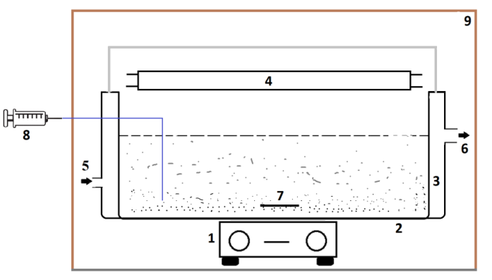
Fig. 1. Schematic diagram of the laboratory-scale experimental setup used. 1- Magnetic stirrer, 2- Batch photo reactor, 3-Jacket water, 4- UV lamp, 5- Cooling water supply from thermostat, 6- Cooling water return, 7- Magnetic bar, 8- Sampling system, 9-Dark wooden box.
Analytical Procedure
The lamp was switched on to start the reaction in the UV/ZnO process. The pH was adjusted applying a Basic pH Meter, PT-10P Sartorius Instrument, Germany by adding NaOH or H₂SO₄ (0.1 M). pH was studied in the range from 3 to 11. The tests were performed by regulating one factor, while others were held fixed.
Samples were withdrawn, centrifuged and filtered, then the concentrations of AR283 were determined by measuring the absorbance at the maximum wavelength of 521 nm by a single beam UV/Vis spectrophotometer (Agilent, 5453, U.S.A.) [12]. The mineralization of AR283 was estimated from the COD test. The COD value was obtained by dichromate closed reflux with a colorimetric method. A spectrophotometer (DR5000, Hach, USA) was applied for measuring the absorbance of COD samples at 600 nm [13]. The percentage removal of color was obtained by the difference in the absorbance values of the initial and the final samples. For further proof, samples were tested by HPLC (Knauer, Germany) equipped with spectrophotometer (Plate blue, Germany). A reverse-phase column, packed with 3 μm Separon C₁₈, was 150 mm in length and 4.6 mm in diameter. The isocratic method was used with a solvent mixture of 70% acetonitrile and 30 % deionized water with a flow rate of 1 ml/min.
The percentages of decolorization and degradation were calculated from equations 1 and 2:
$Removal of AR283\left(\%\right)=\left(\frac{{[AR283]}_{0}-[AR283]}{{[AR283]}_{0}}\right)×100$ (1)
$Removal of COD\left(\%\right)=\left(\frac{{[COD]}_{0}-[COD]}{{[COD]}_{0}}\right)×100$ (2)
where [$AR283$]₀, and [COD]₀ are the concentrations of $AR283$ and COD at the start of the reaction, respectively. [$AR283$] and [COD] are the concentrations of AR283 and COD at time t, respectively.
RESULTS AND DISCUSSION
Mechanism of photocatalytic degradation
As it can be seen from the following equations, when ZnO was irradiated by UV light, degradation and mineralization of AR283 occurred. The photocatalytic degradation of organic pollutant in the solution is originated by photo excitation of the semiconductor, followed by the creation of an electron–hole pair on the surface of the catalyst (Eq. 3). The high oxidative potential of the hole (h_{VB+}) in the catalyst certificates the direct oxidation of the organic pollutant (AR283) to reactive intermediates (Eq. 4). The hydroxyl radicals can be produced by breakdown of water (Eq. 5) or by the reaction of the positive holes with hydroxide ions (Eq. 7).
ZnO+hv<387 nm $→$ $e_{CB}^{-}$+$h_{vb}^{+}$ (3)
$h_{vb}^{+}$+AR283$→$intermediates$→$CO₂+H₂O (4)
H₂O+$h_{vb}^{+}→{OH}_{ads}^{•}$+$H^{+}$ (5)
OH• + AR283 $→$ intermediates +${OH}_{ads}^{•}$ $→$ CO₂ + H₂O (6)
$h_{vb}^{+}$+${OH}_{ads}^{-}→{OH}_{ads}^{•}$ (7)
e_{CB−}+O₂→O₂^{•−} (8)
O₂^{•−}+dye→dye−OO• (9)
O₂^{•−}+HO₂•+H⁺→H₂O₂+O₂ (10)
The hydroxyl radical is a very strong and non-selective oxidant that results from the degradation of organic pollutants [14]. The electron in the conduction band can reduce the molecular oxygen in the solution to form superoxide anion radicals (Eq. 8). These radicals, in the presence of organic scavengers, can form organic peroxides (Eq. 9) or hydrogen peroxide (Eq. 10). The molecular oxygen is an electron acceptor that can prevent from recombination of electron and holes.
Influence of catalyst concentration
The experiments were performed by changing the concentration of ZnO from 0.15 to 0.4 g/l, while the other variables remained fixed (Fig. 2). Experiments showed that the degradation was improved from 70.5 to 98%, with increase in ZnO concentration from 0.15 to 0.3 g/l until it reached a plateau, then it slightly decreased. Above 0.3 g/l of catalyst, the rate of AR283 disintegration was not further affected by advanced increase in ZnO concentration because of the aggregation of catalyst particles at high dosages, causing a decrease in the number of active sites on the surface of catalysts. Besides, further increase in catalyst loading may cause opacity, increase light scattering and reduction of light penetration. So the overall number of photons that can reach the surface of catalyst decreased. Consequently, the efficiency of the produced OH radicals dropped [15,16]. So, 0.3 g/l of catalyst was selected as the optimal content of photocatalyst. By an increase in the amount of catalyst to 0.4 g/l decomposition decreased to 97%.

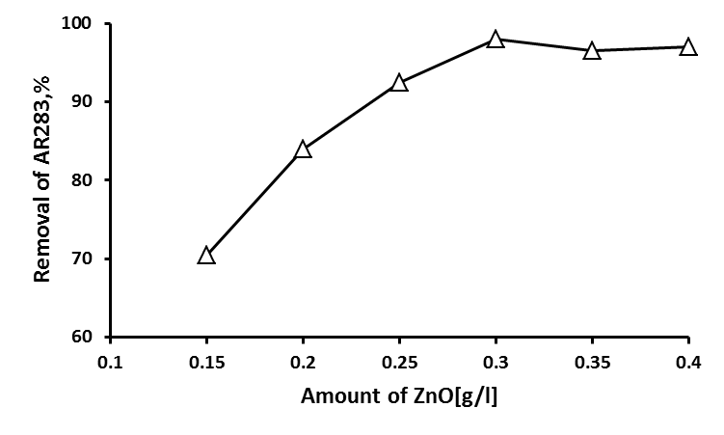
Fig.2. Effect of ZnO amounts on the removal efficiency of AR283 ([AR283]₀ =25 mg l⁻¹, pH= 7, 60 min of reaction)
Effect of initial pH of the solution
The effect of initial pH on the efficiency of the UV/ZnO process was investigated using solutions with different pH values from 3 to 11. The process has the highest efficiency at pH 8.0, as is illustrated in Fig. 3. The best pH for the degradation was near to the zero point of charge (ZPC) of the catalyst and this was explained with the effect of pH on the degradation rate depending on its influence on the catalyst particles.
The zero point of charge pH (pH_{zpc}), at which the surface charge of the ZnO is zero, was about 9.0. Thus, in acidic media, the surface of the catalyst is positively charged and this could be the most probable cause for the low efficiency of the process. These properties produced changes in the structure of dyes at various pH and adsorption on the catalyst surface [17]. In addition, low effectiveness of this process at low pH (pH=3) (54.5%) could be caused by the surface charge of the catalyst at these pH values and the corrosive properties of the solution. The degradation was improved by an increase in pH and maximum degradation (99.5%) was achieved at pH 8.
However, further increase in pH caused decrease in degradation. In alkaline conditions Coulombic repulsion between ${OH}^{-}$ and the negatively charged surface of the catalyst particles could stop the formation of hydroxyl radicals and lessen the degradation. The removal efficiency decreased to 83% at pH 11, because the molecules of AR283 were in ionic form in the alkaline medum and could not adsorb on the ZnO surface that is negatively charged at pH higher than 9.
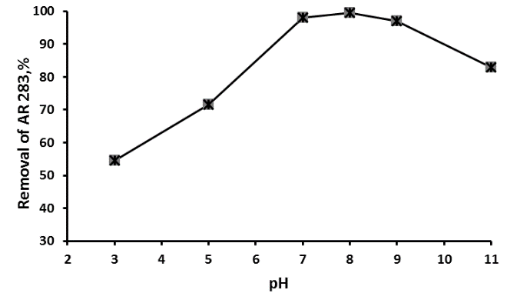
Fig. 3. Effect of pH on the degradation of AR283 ([ZnO] =0.3 g/l, irradiation time= 60 min).
Effect of initial concentration of AR283
The effect of initial concentration of AR283 on photocatalytic degradation efficiency is presented in Fig. 4. It can be seen that the color removal efficiency was reduced as the initial dosage of AR283 increased. The supposed reason is that more dye molecules are adsorbed on the surface of the ZnO catalyst when the initial concentration of AR283 was increased. The amount of adsorbed dye on the surface at different concentrations can be approximately estimated by a spectrophotometric method. The large amount of adsorbed dye has an inhibiting influence on the reaction of the dye molecules with photogenerated holes or hydroxyl radicals. When the concentration of dye is increased, it causes the dye molecules to absorb light and the photons never touch the photo catalyst surface, therefore the photo catalytic degradation efficiency decreased [18].
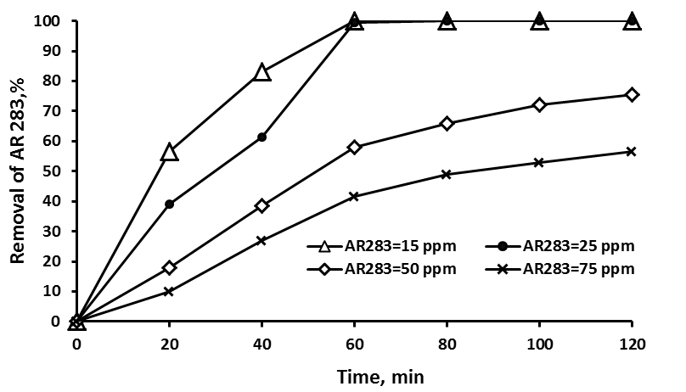
Fig. 4. Effect of initial concentration of AR283 on photo catalytic degradation efficiency ([ZnO] = 0.3 g l⁻¹, pH =8).
Effect of UV irradiation and ZnO nanoparticles
When the pollutant was irradiated with UV light for 120 min, negligible degradation (8.5%) happened. The same experiments were performed in the presence of ZnO without UV light and only 5.5% of AR283 disappeared because of adsorption of pollutant on the surface of the catalyst. Almost 99.5% of AR283 was degraded in the presence of ZnO along with UV light at 60 min of reaction. The hydroxyl radical was an extremely strong, non-selective oxidant that provided the degradation of the organic pollutant [19] and this happened only on simultaneous use of catalyst and UV irradiation. As it can be seen from Fig. 5, decolorization of the AR283 solution was achieved effectively, and more than 61.5% of the dye was removed within 40 min of the reaction, although only 47% of COD were removed during 60 min of reaction. The chief mechanism for decolorization of azo dyes is the breaking of the N=N bond [20]. During the photo-assisted reactions, activated hydrogen atoms were produced which may attack the azo bond and convert it to a hydrogenated azo bond structure, which may absorb UV light at 254 nm [21].
The removal of AR283 was insignificant in the absence of ZnO nanocatalyst, which suggested that both UV light and photocatalyst were required for the effective degradation of AR283.
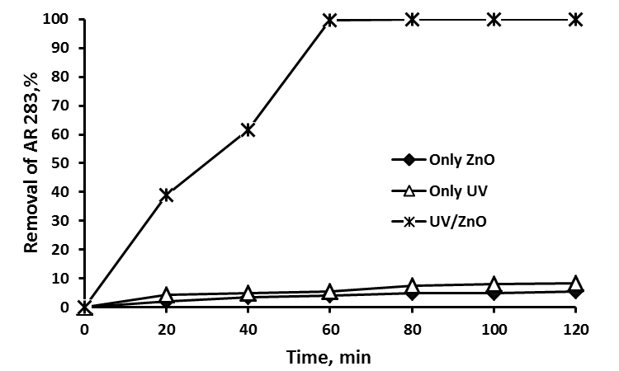
Fig. 5. Effect of various processes upon degradation of AR283 in optimum conditions ([ZnO] = 0.3 g/ l, pH = 8).
Removal of COD
As it can be seen from Fig. 6, COD decreased during the treatment process, but with a slower rate.
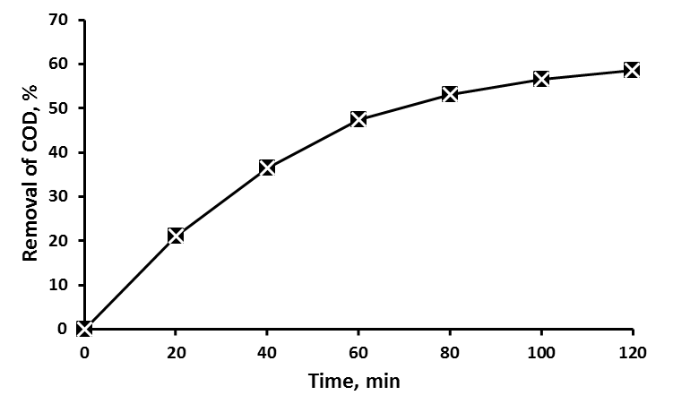
Fig. 6. Removal of COD in optimum conditions ([ZnO] = 0.3 g/ l, [AR283] =25 mg/l, pH = 8).
These values were lower (47.5% in 60 min) than the ones corresponding to the AR283 degradation (99.5% in 60 min), because intermediates were produced in the treatment process. In addition, in the first 60 min of reaction the rate of COD removal was higher, then it decreased with the progress in the treatment process because intermediates were produced continuously and they were persistent to the photocatalytic degradation. After 120 min of reaction 58.5% of COD was removed in optimum condition for degradation of AR283.
Kinetics of Acid red 283 degradation
The relationship between the initial degradation and initial concentration of organic dyes in a heterogeneous photocatalytic degradation process was described by the Langmuir–Hinshelwood model. Usually this model was used to describe the kinetics of photocatalytic degradation in aqueous suspensions [22]. It relates the degradation rate ($R_{AR283}$) and the concentration of organic compound ($C_{AR283}$), as follows:
$R_{AR2}=\frac{k_{r}K_{ad}C_{AR283}}{1+K_{ad}C_{AR283}}$ (11)
where k_{r} and K_{ad} are the rate constant and adsorption equilibrium constant, respectively. In this study, the adsorption was relatively weak and the concentration of AR283 was low (25mg/l), so Eq. 11 can be simplified to pseudo first-order kinetics with an apparent rate constant, k_{app} [7]:
$R_{AR2}=k_{r}K_{ad}C_{AR283}=k_{app}C_{AR283}$ (12)
From the experimental results, the kinetic constant of the reaction was obtained by fitting the experimental data into pseudo first-order kinetic equation. However, when the experimental data were plotted, they looked like a first-order reaction with respect to AR283 decomposition. Therefore, an approach to this kinetic study was performed by assuming that the degradation reaction followed first-order kinetics. This methodology was in agreement with studies of several authors [23,24]. Behnajady et al. stated the Langmuir–Hinshelwood equation factors for decolorization of a solution containing C.I. Acid yellow 23 (40 mg l⁻¹) in the presence of ZnO to be 750 mg l⁻¹ [14]. After integration, from Eq.12 the following equation was obtained:
$ln\left(\frac{{[AR283]}_{0}}{[AR283]}\right)$=${ K}_{app}×t$ (13)
A plot of ln([AR283]₀/[AR283]) versus time for the degradation of AR283 is shown in Fig. 7. By employing least square regression analysis the values of k_{obs} were obtained.
To evaluate these rate constants, $ln\left(\frac{{[AR283]}_{0}}{[AR283]}\right)$ versus reaction time was plotted, and after linear regression analysis, the first-order rate constant (k=27.2$×{10}^{-3}\min^{-1}$ ) and the half-life of the reaction ($t_{1/2}=25.5 min$ ) were determined.
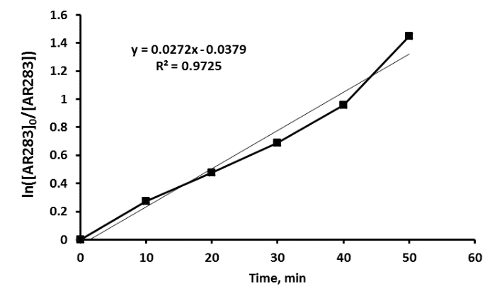
Fig. 7. Kinetic fit for the degradation of AR283 by UV/ZnO process in optimum conditions ([ZnO] = 0.3 g/ l, [AR283] =25 mg/l, pH = 8).
CONCLUSIONS
The results of this study showed that:
UV/ZnO process could be successfully used to degrade AR283 in a batch photoreactor with system light and oxygen, but UV light and ZnO had a slight effect when they were used separately. Experiments were performed to find out the optimum conditions to achieve high degradation rates needed for the photocatalytic process.
The degradation of AR283 was obviously affected by the irradiation time, initial concentration of pollutant, pH and dosage of ZnO. The optimal conditions for the degradation were: 0.3 g/l of photocatalyst, 25 mg/l of AR283 and pH 8. The removal of COD (58.5% in 120 min) was slower than the removal of AR283 (99.5% in 60 min) because of the persistent intermediates formed through degradation.
Photocatalytic degradation of AR283 in aqueous ZnO suspensions follows pseudo-first-order kinetics and the apparent rate constant ($k_{app}$ =27.2$×{10}^{-3}\min^{-1}$) depends on the initial concentration of AR283.
Acknowledgement: The authors wish to thank the HSE department of the national petrochemical company of Iran for scientific guidance.
REFERENCES
1. M. I. Badawy, M. Y. Ghaly, T. A. Gad-Allah, Desalination, 194, 166 (2006).
2. E. Bazrafshan, M. Ahmadabadi, A. H. Mahvi, Fresen. Environ. Bulletin, 22, 584 (2013).
3. S. Parsons, Int. Biodeter. Biodegr., 46, 51 (2004).
4. A. Dalvand, R. Nabizadeh, M.R. Ganjali, M. Khoobi, S.Nazmara, A.H. Mahvi, J. Magn. Magn. Mater., 404, 179 (2016).
5. H. Jayamohan, Y. R. Smith, B. K. Gale, S. K. Mohanty, M. Misra, J. Environ. Chem. Eng., 4,657 (2016).
6. A. Shokri, K. Mahanpoor, Int. J. Ind. Chem., 8, 101 (2017).
7. A. Shokri, K. Mahanpoor, D. Soodbar, Fresen. Environ. Bull., 25, 500 (2016).
8. B. Cuiping, X. Xianfeng, G. Wenqi, F. Dexin, X. Mo, G. Zhongxue, X. Nian, Desalination, 278, 84 (2011).
9. N. Guettai, A.H Ait, Desalination, 185, 427 (2005).
10. A. Shokri, K. Mahanpoor, D. Soodbar, J. Environ. Chem. Eng., 4, 585 (2016).
11. N. Daneshvar, D. Salari, A. R. Khataee, J. Photochem. Photobiol. A: Chem., 162, 317 (2004).
12. K. Jirasripongpun, R. Nasanit, J. Niruntasook, B. Chotikasatian, Thammasat Int. J. Sci. Technol., 12, 6 (2007).
13. APHA, AWWA, WEF, Standard Methods for the Examination of Water and Wastewater, 19 th ed., APHA, Washington, USA, 1995.
14. M.A. Behnajady, N. Modirshahla, R. Hamzavi, J. Hazard. Mater., 133, 226 (2006).
15. H. Zhao, S. Xu, J. Zhong, X. Bao, Catal. Today, 93, 857 (2004).
16. A. Mehrizad, P. Garbani, Photobiol. Photochem., 93, 1178 (2017).
17. H. Moradi, S. Sharifnia, F. Rahimpour, Mater. Chem. Phys., 158, 38 (2015).
18. A. Mehrizad, P. Garbani, Water Science Technol., 74, 184 (2016).
19 A. Shokri, K. Mahanpoor, D. Soodbar, Desal. Water Treat., 57, 16473 (2016).
20. N. Daneshvar, D. Salari, A.R. Khataee, J. Photochem. Photobiol., 157, 111 (2003).
21. W. Feng, D. Nansheng, H. Helin, Chemosphere, 41, 1233 (2000).
22. N. Daneshvar, S. Aber, M.S. Dorraji, A.R. Khataee, M.H. Rasoulifard, Sep. Purif. Technol., 58, 91 (2007).
23. N. Barka, I. Bakas, S. Qourzal, A. Assabbane, Y. Ait-ichou, Orient. J. Chem., 29,1055 (2013).
24. A. Shokri, Russ. J. Appl. Chem., 90,452(2017).

Използване на UV/ZnO процес за разграждане на Кисело червено 283 в синтетична отпадна вода
A. Шокри¹*, К. Маханпоор²
¹ Елитен клуб на младите изследователи, Клон Арак, Ислямски Азад университет, Арак, Иран
² Департамент по химия, Научен факултет, Клон Арак, Ислямски Азад университет, Арак, Иран
Постъпила на 28 февруари 2017 г.; приета на 23 декември 2017 г.
(Резюме)
В настоящата статия е изследвана фотокаталитичната деградация на Кисело червено 283 (КЧ283) чрез УВ/ZnO процес в статичен фотореактор. Установено е, че използвани поотделно, нанокатализаторът ZnO и УВ светлината влияят слабо върху процеса. Изследвано е влиянието на различни фактори като изходно рН, изходни концентрации на багрилото и катализатора върху ефективността на деградацията. Деградацията и минерализацията на КЧ283 са оценени с помощта на високоефективна течна хроматография и тест за химично необходим кислород (ХНК). При оптимални условия (0.3 g/L катализатор, pH 8 и изходна концентрация на багрилото 25 mg/l), отстраняването на КЧ283 и ХНК са съответно 99.5 и 58.5% при 60 и 120 минутна реакция. Кинетиката от псевдопърви порядък на отстраняването на КЧ283 се обяснява с модела на Langmuir–Hinshelwood. Определена е привидната скоростна константа на процеса ($k_{app}$ =27.2$×{10}^{-3}\min^{-1}$).

