Editorial
On the occasion of the 50th volume of our journal
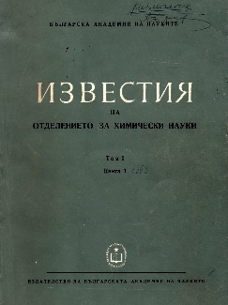
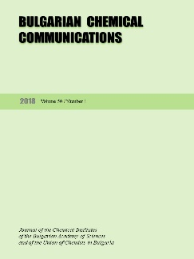
It was in 1968, when our journal has been founded. Its first name was “Communications of the Department of Chemistry” at the Bulgarian Academy of Sciences. The editorial board has included Bulgarian scientists only, but all of them with significant contributions to chemistry in the world science as a whole. There were the prominent names of D. Ivanov and B. Kurtev in organic chemistry, R. Kaischev and S. Hristov in physical chemistry, G. Bliznakov in inorganic chemistry and catalysis, D. Elenkov in chemical engineering, N. Yordanov and A. Trifonov in analytical chemistry, D. Shopov in organic catalysis, I. Panayotov in polymer science, etc. There were no foreign members of the editorial board, which was understandable for that period of time, but the names of the Bulgarian scholars in the list were good pledge for the journal quality. There were four regular issues annually for each volume.
This journal was a continuation of five separate journals on different areas of chemistry appearing in different periods from 1951 to 1967, but with modest success due to the potentials of the three existing chemical institutes in that period of time. The integration of the efforts of the Bulgarian scientists in chemistry had positive impact on the journal quality and encouraged the efforts of other Bulgarian scientists to publish their results in it. The Bulgarian Academy of Sciences was able to support financially the publication activity of its institutes. Since that time the journal is one of the Bulgarian academic issues included in the international exchange of periodicals due to its broad profile.
Until 1989 the journal was written in Bulgarian mainly with sporadic articles in other languages (Russian, English, German and French) which did not contribute to its international authority and acquaintance. After that (in 1992) it was decided to edit the journal in English only, with abstracts in Bulgarian at the end of each paper. The formal name was changed to Bulgarian Chemical Communications with translation into Bulgarian. There was an international editorial board composed in this period of time. Since 1992 the editorial board decided to publish issues dedicated to anniversaries of famous scholars in chemistry or comprising the contributions to different scientific events.
The new political and economic conditions, as well as the freedom of choice of the Bulgarian scholars to publish their scientific results abroad wherever they wanted led to a certain loss of interest to our journal. It was a hard period of time, when for the editors was difficult to find funds for the publishing process, as well as to convince the chemists in Bulgaria and abroad to publish their results in our journal. It was a critical period for the existence of the journal at all. The support of the National Scientific Fund and of some other foundations was very important for the journal survival and its further development and progress.
There was an impact-factor assigned to the journal by Thomson-Reuters in 2010. This fact had a crucial importance for the journal authority and the interest to it. Since that time the progress is enormous: there are more than 20 papers in each regular issue. Many special issues dedicated to anniversaries or conference proceedings are published. Now the contributors to the journal are from more than 25 countries throughout the globe. There were thirteen such special issues for the year 2017 and twelve more are planned for 2018! After the hard times in the 1990s the future of BCC seems brighter and more successful.
Here is suitable to mention the contribution of all members of the editorial board as well as the efforts and expertise of the journal scientific secretaries, i.e. Prof. A. Trifonov, Assoc. Prof. G. Kadinov, Assoc. Prof. Ch. Bonev, Prof. D. Yankov and Prof. E. Ivanova. Let us hope that BCC will progress in future strengthening its international authority and significance.
Prof. Venko Beschkov
Editor-in-Chief

