Responsible structural features for cytotoxic and other kinds of activity of neo-clerodane diterpenes from genus Scutellaria
K. H. Nikolova¹, I. T. Stoykov², P. I. Bozov¹*
¹Department of Biochemistry and Microbiology, Plovdiv University, 24 Tsar Assen Str., 4000, Plovdiv, Bulgaria
²Institutе of Molecular Biology, BAS, 21 Acad. G. Bonchev Str., 1113, Sofia, Bulgaria
Received July, 26, 2017; Revised October 25, 2017
Twelve natural neo-clerodane diterpenes, isolated from three Scutellaria (Labiatae) species, were tested for cytotoxicity on two cell lines, from human tumors of the lung designated as H1299 and normal cells from a navel string (HUVEC), using the MTT (3-/4,5-dimethylthiazol-2-yl/-2,5-diphenyltetrazolium bromide) method. The cytotoxic activity was evaluated as rate of IC₅₀ (such concentration of the compound in µM by which half of the cells die). Three compounds, scutalpins A, E and F, exhibited moderate cytotoxic properties on both cell lines. Among all tested compounds the highest activity was detected for scutalpin A, with IC₅₀ values of 21.35 and 23.9. Some significant aspects of the relationship structure-activity are discussed.
Key words: Scutellaria; Diterpenes; Cytotoxic, Antifeedant, Antifungal activities.

INTRODUCTION
The natural neo-clerodane diterpenoids, isolated from Scutellaria species, draw attention because of their varied biological activities especially as potent insect antifeedants [1-4] and antifungal [5] agents against plant pathogenic fungi.
All diterpenoids isolated from the species of genus Scutellaria (Labiatae) are with neo-clerodane skeleton (1, Fig. 1) which Bruno et al. divided in two part substructures bearing different substitutes [1]. The first substructure, including the carbon atoms from C-1 to C-10, is always a trans-bound bicyclic system - decalin core. The second one covers the carbon atoms C-11– C-16 and consists of different fragments: tetra- (2a, Fig. 2) or hexahydrofurofuran system (2b); α,β-unsaturated-γ-lactone (3) junked between C-13 – C-16; γ-lactone 13-spiro, bound up with cyclic ether inclusive C-8 and forming two epimers with C-13S (4) and C-13R (5) configurations. Finally, in the C-11 – C-16 substructure may be formed a lactol ring that comprises carbons C-11, C-12, C-13, C-16 (6) or carbons C-13 – C-16 (7).
* To whom all correspondence should be sent:
E-mail: bozov@uni-plovdiv.bg
© 2018 Bulgarian Academy of Sciences, Union of Chemists in Bulgaria
Clerodanes, obtained from Scutellaria plants, displaying the above activities, predominantly possess a decalin ring with C-4-C-18 spiro-epoxide and two acetate groups at C-6 and C-19 positions and 2a or 2b moiety in the C-11 – C-16 fragment. The compounds clerodin (8), jodrellin A (9) and jodrellin B (10) exhibit strong antifeedant activity. Particulary 10 was reported to be the most potent antifeedant known to date [4]. These three compounds have been assayed for antifungal activity against the plant pathogenic fungi Fusarium oxysporum f. sp. lycopersici and Verticillium tricorpus. Spore germination of V. tricorpus was delayed by clerodin and jodrellin B.
1, 8, 9: R = Ac; 10: R = CO^{i}Pr
Figure 1. Neo-clerodane skeleton (1), clerodin (8), jodrellin A (9) and jodrellin B (10)
Growth of F. oxysporum and V. tricorpus was inhibited by the clerodanes in a dose-dependent manner [5].
To the best of our knowledge the neo-clerodane diterpenoids from Scutellaria species have not been studied for other biological properties. In continuation with our research on this topic we had examined neo-clerodane diterpenoids, isolated in our laboratory, for antifeedant activity against Leptinotarsa decemlineata (Say) [6,7] and that study confirmed results achieved in previous works. Subsequently, we tested these compounds for antioxidant effects but none of the diterpenes showed such activity. The next step was to evaluate the influence of these clerodanes on pathogenic and food spoilage microorganisms.
X-Y 3 4 5 6 7
2a: HC=CH R = H; Me R = Alkyl
2b: H₂C—CH₂ R¹ = Acyl
Figure 2. C-11 – C-16 moiety
We concluded that the compounds, containing fragment 4 or 5 in their structures, exhibit antimicrobial activity while the compounds possessing the other kind of C-11 – C-16 moiety are inactive [8].
Herein we report the results from the bioassay of natural neo-clerodane diterpenoids, isolated from the acetone extracts of the aerial parts of three Scutellaria species, for cytotoxic activity on H1299 and HUVEC cell lines.
EXPERIMENTAL
Plant material: The stems of all plants were collected during their blossoming as follows: scutellaria alpina in August 1991, at Pirin Mountains, near Bansko, Bulgaria; Scutellaria galericulata in June 2012, near Lovech and Pleven, Bulgaria; Scutellaria altissima in June 2011, in Bachkovo, near Assenovgrad, Bulgaria.
Structural data: ¹H NMR spectra were recorded on Bruker DRX-250, Varian Mercury-400 or Bruker Avance II+ spectrometers, operating at 250.13 MHz, 400.13 or 600.130 MHz, respectively. ¹³C NMR spectra were recorded at 100.61 and 150.903 MHz, respectively, on the corresponding spectrometers. TMS was used as internal standard and CDCl₃ as solvent. Chemical shifts (δ) are expressed in ppm and coupling constants (J) in Hertz. The IR spectra were registered in KBr pellets on a Perkin-Elmer 1750 FT-IR spectrometer from 4000 cm⁻¹ to 450 cm⁻¹ at resolution 4 cm⁻¹ with 9 scans. MS and HRMS spectra were registered on Accela quaternary UHPLC pump with Accela autosampler and HRMS “Q-Exative” detector (Thermo Fisher Scientific, Waltham, MA, USA) with heated electro spray (H-ESI) interphase.
Extraction and isolation: Dried and finely powdered aerial parts of the plants were extracted with Me₂CO threefold at room temperature for a week. After filtration, the solvent was evaporated to dryness under reduced pressure and low temperature (<40 °C) yielding a gum, which was dissolved in aq. Me₂CO (40 % H₂O, v/v, 100 mL). This solution was cooled to 4 °C for 24 h and filtered. The filtrate was extracted with CHCl₃ and the organic layer was dried (Na₂SO₄) and evaporated in vacuum to afford a residue (bitter fraction). This residue was subjected to CC (silica gel Merck n. 7734, deactivated with 10% H₂O, w/w). Pure petroleum ether, followed by a gradient of petroleum ether - EtOAc mixtures (10:1 to 4:1) and dichloromethane were used first as eluting solvents. The diterpene fractions (TLC monitoring) were eluted with 1% to 3% methanol in DCM. Rechromatography or repeated prep TLC of these fractions (2% methanol in DCM or EtOAc as eluent) afforded crude compounds. Crystallization and recrystallization from acetone yielded pure diterpenes.
Test compounds: All tested neo-clerodane diterpenoids (Fig. 3) were available from previous investigations. 14,15-dihydrojodrellin T (10), neoajugapyrin A (11), scutegalerin A (12), scuecolumnin C (13) and scutegalin D (20) were retrieved from Scutellaria galericulata L. as described above [10, 11]. Scutecyprol A (14), scupolin H (15), clerodin (16) and scutaltisin G (21) were isolated from Scutellaria altissima L. [12, 13]. Diterpenoids scutalpin A (17), scutalpin F (18) and scutalpin E (19) were obtained from Scutellaria alpina L. [14, 15]. The molecular structures of the compounds were established by spectroscopic means: IR spectroscopy, MS, 1D (¹H, ¹³C including Dept 125) and 2D (HSQC, HMBC, ¹H-¹H COSY, NOESY) NMR experiments. Absolute configuration of scutalpin A was determined by X-ray diffraction analysis.
Diterpenoids have been kept in the refrigerator at 4ºC. Before doing the cytotoxicity bioassays we measured and compared with the literature the melting points and the IR spectra of the tested compounds. The purity of the compounds was checked by TLC with different solvents (diethyl ether, ethyl acetate, from 1% to 3% methanol in DCM).
Cytotoxicity bioassays. Summary. Cell lines: For the in-vitro cytotoxic activity screening, two cell lines were selected: from human tumors of the lung, designated as H1299, and normal cell lines HUVEC (cells from a navel string). The cell lines were obtained from BPS Bioscience, Recombinant Cell Lines & Assay Kits. The bought cells were sustained in the artificial medium (DMEM – HUVEC; RPMI – H1299) and often resewed. Stock solutions: The working probes were prepared by dissolution of 1 mg of diterpenoides in 50 µL of DMSO (dimethylsulfoxide). To obtain the tests solutions two or three µL from the DMSO solutions of the compounds were diluted in 1 mL culture medium as the concentration of DMSO in the tests solutions became 0.2 – 0.3 %.. For bioassays we took so much quantity of the tests solutions that after subsequent diluting in the culture medium, to ensure a concentration in 125 µL of 300, 150, 75, 37.5 and 19 µM. In such conditions the diterpenoids remained well soluble and did not react with the solvent DMSO and the components of the culture medium, based on the TLC monitoring. Pure water was used for the control probe. Four repetitions of assays were made for each concentration. The influence of different concentrations of DMSO on the cytotoxic activity on the cell lines was studied. This step is important because the terpenoids have only poor water solubility and usage of compatible organic solvents such as DMSO is required. Cytotoxic effect for the cells was observed in the mixture of DMSO/water with w/w of DMSO of 1%. Concentration of DMSO in the working probes ranged between 0.1 and 0.007%.
МТТ assay: Cells (0.5 × 10⁴ – 1 × 10⁴) were plated in 125 µL of medium/well in a 96–well plate. After seventy-two hours we threw the old nutritive medium together with the compound and added a new medium with the dissolved МТТ. The cell mitochondrial respiratory chain should include MTT and if the cell is alive and breaths its color changes from yellow to purple. After four hours the medium + МТТ was thrown and the remains, that were bottom purple crystals МТТ (phurmazanic), were dissolved with 2% solutions of formic acid in iso-propanol. The intensity of the purple tinge was measured with the device, ELISA reader. The data were processed with the program GraphPadPrism. Activity was evaluated as rate of IC₅₀.
RESULTS AND DISCUSSIONS
Twelve natural neo-clerodane diterpenes (Fig. 3), isolated from Scutellaria galericulata L., Scutellaria alpina L. and Scutellaria altissima L., growing in Bulgaria, were tested for cytotoxicity on two cell lines, from human tumors of the lung designated as H1299 and normal cells from a navel string (HUVEC), using the MTT method. The cytotoxic activity was evaluated as rate of IC₅₀.
Characteristic signals for the neo-clerodane skeleton in all tested diterpenoids were easily determined at δ_{H} in the region 1.10-1.20 s (Me-20), 0.78-0.95 d (Me-17) and 1.75-2.25 d or dd (H-10β). The decalin moiety contains some constant functional features: the decalin junction is always trans; methyl groups C-17 and C-20 are always α-orientated; α-hydroxy or α-acyloxy groups are always present on carbons C-6 and C-19; while carbon C-10 is never functionalized; bearing C-4–C-18 spiro-epoxide. The two doublets from the AB quartet corresponding to the C-18 two hydrogens appeared at the region of δ_{H} 2.40-2.50 for H-18A and 2.95-3.05 for the H-18B, respectively. In compounds having substitute at third position the signal for 18A is replaced at δ_{H} 2.85-2.92.
In accordance with the aim of this investigation the compounds were separated into four groups I-IV on the basis of the presented C-11 – C-16 substructures (Fig. 3). Members of the I (diterpenoids from 10 to 14) have hexahydrofurofuran moiety (2b) (1H, δ_{H} 2.80-2.95 br tt, H-13; 1H, δ_{H} 5.60-5.70 d, H-16) and display a 2α,19-hemiacetal or acetal function (1H, δ_{H} 3.98-4.10 ddd, H-2β) with the exception of 14.
R¹ R² R³ 14,15-Dihydrojodrellin T (10): Otig H OAc Scutecyprol A (14): R¹, R² = H, OH Scupolin H (15) Neoajugapyrin A (11): H OH Otig (R and S form) Scutegalerin A (12): OH H Otig Scutecolumnin C (13):H OH

Separate compounds differ from one another by the substitutes at C-1, C-3 or C-19 position. In the second group (II) are included two clerodanes 15 and 16 which contain the fragment 2a (1620 cm⁻² vinyl ether; 1H, δ_{H} 4.81 t, H-14 / δ_{C} 102.0 d; 1H, δ_{H} 6.45 t, H-15 / δC 146.7 d). The series III was constructed by three diterpenoids, scutalpins A, E and F, as the configuration of the carbon C-13 in
R R¹ R² Clerodin (16) Scutalpin A (17): MeBu Scutalpin E (19) Scutegalin D (20): Tig H Scutalpin F (18): Ac Scutaltisin G (21): H CH₃
Figure 3. Molecular structures of the tested neo-clerodane diterpenoids
scutalpin E (1H, 2.48 d, H-14α; 1H, 3.12 d, H-14β / δ_{C} 44.3 t, C-14; 1H, 4.30 d, H-16α; 1H, 4.10 d, H-16β / δ_{C} 79.4 t, C-16 and δ_{C} 173.1 s, C-15)0 is opposed to that in the scutalpins A and F (1H, 2.57 d, H-14α; 1H, 2.73 d, H-14β / δ_{C} 42.6 t, C-14; 1H, 4.13 d, H-16α; 1H, 4.35 d, H-16β / δ_{C} 79.6 t, C-16 and δ_{C} 174.6 s, C-15). The representatives 20 and 21, possessing the lactol ring 6 (δ_{H} 3.86 td, 1H, H-15A; 3.93 td, 1H, H-15B; 4.64 d, 1H, H-16), form the last group IV.
Scutalpins A, E and F, exhibited moderate cytotoxic properties on both cell lines (Table 1), but the rest of the compounds were inactive within the studied concentration range. Based on these results, it could be concluded that the tetra- or hexahydrofurofuran substructures are not the responsible moiety for cytotoxic action, which is in discrepancy with the affirmation from Kojima and Kato, that these structural features of the molecules are accountable conditions for the significant antifeedant activity [15].

Table 1. Cytotoxic activity of neo-clerodane diterpenes on H1299 and HUVEC cell lines
Compounds | IC₅₀ values |  | Compounds | IC₅₀ values
 | H1299 | HUVEC |  | H1299 | HUVEC
14,15-Dihydrojodrellin T (10) | 242,21 | 244,43 | Clerodin (16) | 236,35 | 236,84
Neoajugapyrin A (11) | 288,65 | 287,59 | Scutalpin A (17) | 21,35 | 23,89
Scutegalerin A (12) | 452,01 | 458,00 | Scutalpin F (18) | 26,62 | 31,28
Scutecolumnin C (13) | 667,44 | 665,79 | Scutalpin E (19) | 34,24 | 32,48
Scutecyprol A (14) | 335,76 | 365,32 | Scutegalin D (20) | 888,35 | 883,47
Scupolin H (15) | 578,71 | 574,55 | Scutaltisin G (21) | 892,02 | 892,22

Presumably, there is no correlation between the two kinds of biological activities, cytotoxic and antifeedant. All three compounds with cytotoxic effect, have 13-spiro connected γ-lactone as the configuration of the asymmetric center C-13 is S in 17 and 18 and R in 19, respectively. Diterpenoids differ from one another by the substitute at carbon C-6. The most active among them scutalpin A contains 2-methylbutyrate, while the less active scutalpin F and scutalpin E are presented with acetyl or (E)-2-methyl-2-butenoyl ester. It is uncertain that only changing of the 2-methylbutyrate function with the tiglate one causes the bigger decrease in the action of 19, because the C-11 – C-16 substructure is not with 13S configuration like in scutalpin A, but it is with the other possible orientation - 13R.
CONCLUSION
The achieved results by the series of bioassays on antifeedant activity confirm the previously reported, by Blaney et al. [16]; Houghgoldstein & Whalen [17], dependence of activity on the presence in the molecule of tetra- or hexahydrofurofuran ring. Neo-clerodane diterpenoids do not display antioxidant activity. Compounds which exhibit cytotoxic and antimicrobial activity possess 13-spiro-α,β-unsaturated-γ-lactone. Thus, it be concluded that the higher activity depends on the characteristic features of the whole molecular structure. Responsible structural features for biological activity vary for the separate kinds of properties.
REFERENCES
1. M. Bruno, F. Piozzi, S. Rosselli, Natural Product Reports, 19 (3), 357 (2002).
2. M. Bruno, F. Piozzi, A. Maggio, M. S. J. Simmonds, Biochemical Systematics and Ecology, 30 (8), 793 (2002).
3. E. A. Klein-Gebbinck, B. J. M. Jansen, A. de Groot, Phytochemistry, 61 (7), 737 (2002).
4. J. C. Anderson, W. M. Blaney, M. D. Cole, L. L. Fellows, S. V. Ley, R. N. Sheppard, M. S. J. Simmonds, Tetrahedron Letters, 30 (35), 4737 (1989).
5. M. D. Cole, P. D. Bridge, J. E. Dellar, L. E. Fellows, N. C. Cornish, J. C. Anderson, Phytochemistry, 30 (4), 1125 (1991).
6. P. I. Bozov, T. A. Vasileva, I.N. Iliev, Chemistry of Natural Compounds, 50 (4), 762 (2014)
7. P. I. Bozov, K. H. Nikolova, V. B. Bivolarski, T. A. Vasileva, Journal of BioScience and Biotechnology, SE/ONLINE. (2014).
8. P. I. Bozova, T. Girova, N. Prisadova, Y. Hristova, V. Gochev, Natural Product Communications, 10 (11), 1797 (2015).
9. P. I. Bozov, P. N. Penchev, T. V. Vasileva, I. N. Iliev, Chemistry of Natural Compounds, 50 (3), 554 (2014).
10. P. I. Bozov, P. N. Penchev, J. Coll, Natural Product Communications, 9 (3), 347 (2014).
11. Y. P. Georgieva, R. D. Mladenov, P. I. Bozov, Chemistry of Natural Compounds, 50 (6), 1146 (2014).
12. P. I. Bozov, J. Coll, Natural Product Communications, 10 (1), 13 (2015).
13. P. Bozov, P. Malakov, G. Papanov, M. de La Torre, B. Rodriguez, A. Perales, Phytochemistry, 34 (2), 453 (1993).

14. P. I. Bozov, G. Y. Papanov, P. Y. Malakov, Phytochemistry, 35 (5), 1285 (1994).
15. Y. Kojima, N. Kato, Tetrahedron, 37 (15), 2527 (1981).
16. W. M. Blaney, M. S. Simmonds, S. V. Ley, P. S. Jones, Entomol. Exp. Appl., 46, 267 (1988).
17. J. Houghgoldstein, J. Whalen, Biol. Control, 3, 343 (1993).
НЯКОИ СТРУКТУРНИ ОСОБЕНОСТИ, ОПРЕДЕЛЯЩИ ЦИТОТОКСИЧНОСТТА И ДРУГИ ВИДОВЕ АКТИВНОСТИ НА НЕО-КЛЕРОДАНОВИ ДИТЕРПЕНИ ОТ РОДA SCUTELLARIA
К. Н. Николова¹, И. Т. Стойков², П. И. Бозов^{1 *}
¹ Катедра по биохимия и микробиология, Пловдивски университет, ул. "Цар Асен" 24, 4000, Пловдив, България.
² Институт по молекулярна биология, БАН, 21 Акад. Ул. Г. Бончев, 1113, София, България
Постъпила на 26 юли, 2017 г.; коригирана на 25 октомври, 2017 г.
(Резюме)
Дванадесет природни нео-клероданови дитерпени, изолирани от три вида на родa Scutellaria (Labiatae), са тествани за цитотоксичност на две клетъчни линии, от тумори на човешки бял дроб, означени с H1299 и нормални клетки от пъпна връв (HUVEC) с помощта на МТТ (3-/4,5-диметилтиазол-2-ил/-2,5-дифенилтетразолиев бромид) метод. Цитотоксичната активност е изчислена като IC₅₀ стойност (такава концентрация на съединението в µM, при която половината от клетките умират). Три съединения, скуталпини А, Е и F проявяват умерени цитотоксични свойства за двете клетъчни линии. От всички тествани съединения най-висока активност е отчетена за скуталпин А, със стойности на IC₅₀ съответно 21,35 и 23,9.
Обсъдени са някои значими аспекти на взаимовръзката структура - активност.

SUPPLEMENTARY DATA
In this section the GraphPadPrism experimental results for the cytotoxic active compounds are shown.
Scutalpin A (17)
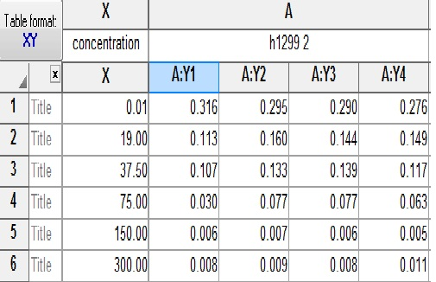 | 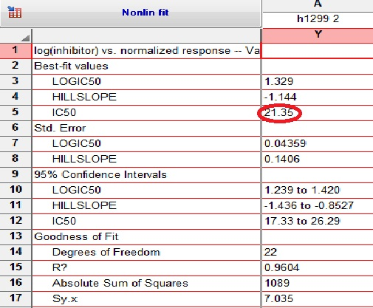
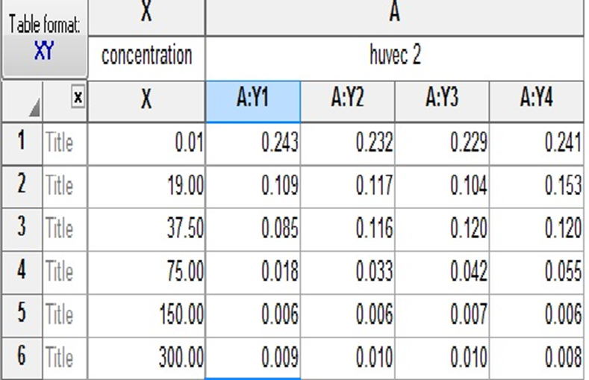 | 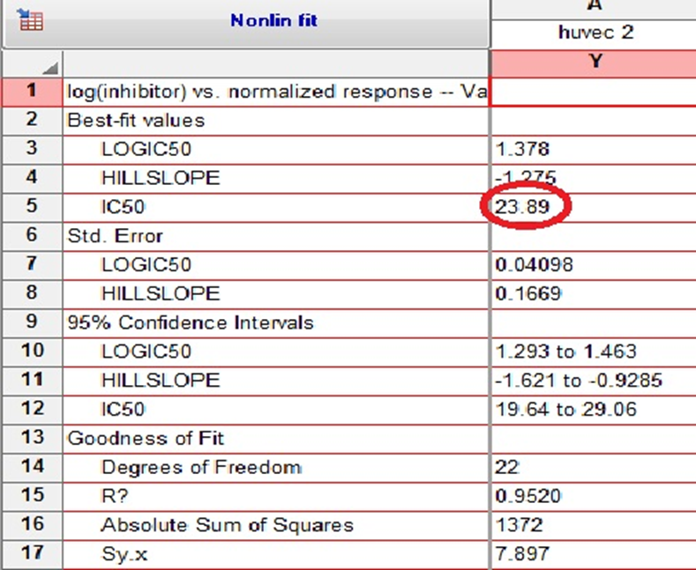

Scutalpin F (18)
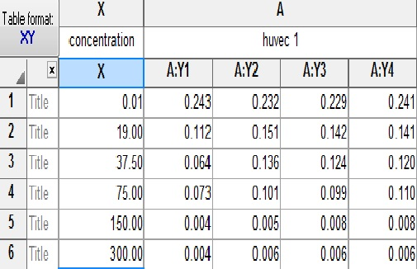 | 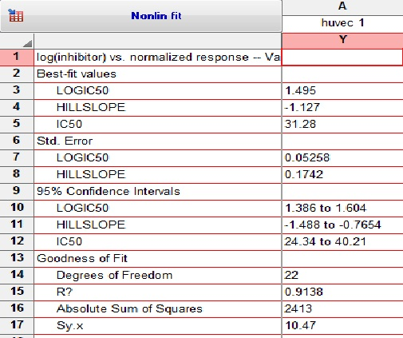
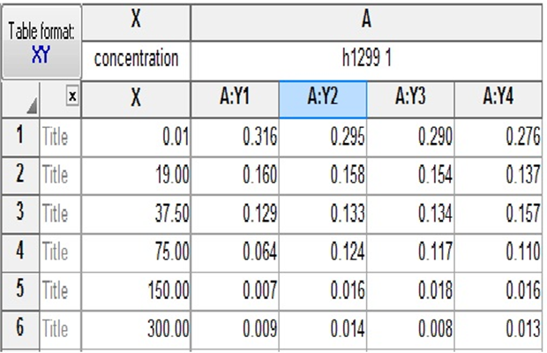 | 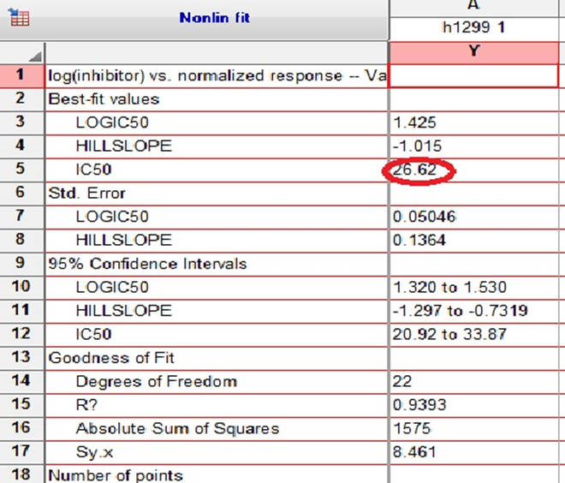
Scutalpin E (19)
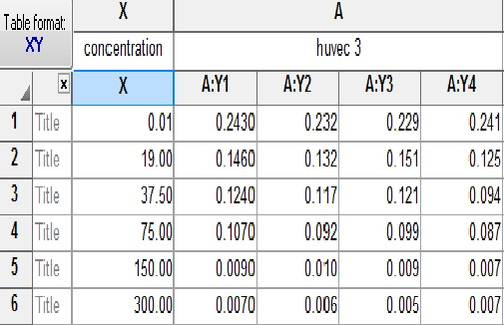 | 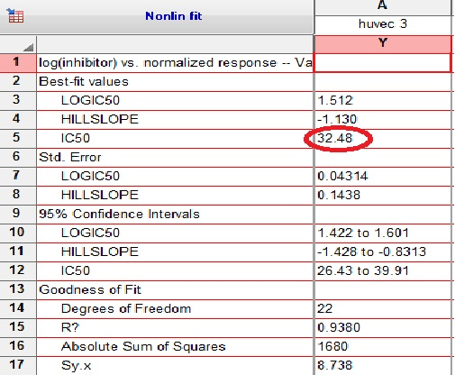
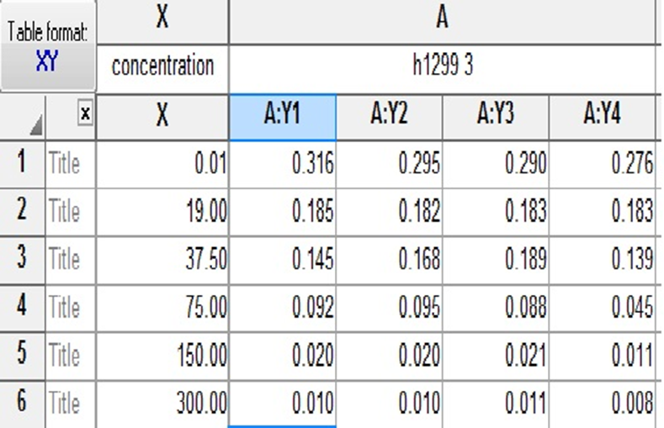 | 