Antioxidant mechanisms in neuroprotective action of lipoic acid on learning and memory of rats with experimental dementia
E. R. Tzvetanova¹, A.P. Georgieva¹, A.V. Alexandrova^{1*}, L. P.Tancheva¹, M. I. Lazarova¹, S. T. Dragomanova^{1,2}, L. G. Alova¹, M. O. Stefanova¹, R. E. Kalfin¹
¹Institute of Neurobiology, Bulgarian Academy of Sciences, 23 Acad. G. Bonchev Str., 1113 Sofia, Bulgaria
²Department of Pharmacology, Toxicology and Pharmacotherapy, Medical University "Prof. Dr. Paraskev Stoyanov", 55, Prof. Marin Drinov Str., 9002 Varna
Received, Revised,
Alzheimer's disease (AD) is one of the most common dementia affecting about 36 million people and without effective cure. Oxidative stress is one of many hypotheses for the AD mechanisms. Possible preventive AD effects of some antioxidants continue to be the object of clinic and experimental research. The aim of this study was to evaluate the antioxidant mechanism in the neuroprotective effect of lipoic acid (LA) on the cognitive functions in experimental dementia. Alzheimer's disease type dementia was produced via scopolamine treatment (Sco, 1 mg/kg i.p., 11 days) on male Wistar rats. Lipoic acid (LA, 30 mg/kg, i.p.) was applied for the same period. Learning and memory performance of the rats were evaluated using passive avoidance learning test (Step through test). At the 24th hour after the last treatment the brain frontal cortex, hippocampus, and striatum were isolated and homogenized. The homogenates were used for determination of malondialdehyde (MDA), total glutathione (tGSH), and activities of superoxide dismutase (SOD), glutathione peroxidase and catalase (CAT). The dementia model was verified by the cognitive tests used. In brain structures of the Sco-group increased MDA, and decreased tGSH levels, as well as activated antioxidant enzymes were observed. LA significantly improved cognitive functions and oxidative status damaged by Sco by increased tGSH level, restored CAT and SOD activities. Thus LA significantly protects memory impairments of dement animals due to its antioxidant capacity and could be used in prevention and therapy of AD.
Key words: Alzheimer's disease, Lipoic Acid, Oxidative stress, Scopolamine

INTRODUCTION
Alzheimer's disease (AD) is the major senile type of dementia. According to The World Alzheimer Report (2016) in 2015 AD has affected about 47 million people. It is considered that this number will reach more than 130 million in 2050. Various hypotheses try to explain the mechanisms of AD, including the oxidative stress (OS). Many studies have shown increased lipid peroxidation, protein and DNA oxidation in the AD brain [1-3]. Since OS is involved in the pathogenesis of the disease it could be assumed that antioxidants would have a beneficial effect. There are evidences that higher intake of vitamin E [4] and vitamin C [5] may reduce the risk of dementia and AD.
Alpha lipoic acid (LA) is an endogenous organosulfur compound that demonstrates considerable antioxidant properties. Lipoate, or its reduced form, dihydrolipoate, reacts with reactive oxygen species such as superoxide radicals, hydroxyl radicals, hypochlorous acid, peroxyl radicals, and singlet oxygen [6]. In addition it can interact with vitamin C and glutathione, which may recycle vitamin E. Moreover it is able to chelate transition metal ions, in particular iron, preventing hydroxyl radicals’ generation via Fenton reaction [7]. A positive effect of LA was shown in a number of pathological conditions with OS ethology [8-11].The effect of LA has been investigated also in some neurodegenerative disorders. Li et al. [12] demonstrated a protective effect of LA on dopaminergic neurons in a model of Parkinson disease through inhibition of intercellular ROS levels and mitochondrial transmembrane permeability. The intraperitoneal administration of LA (30 mg/kg body weight/day) into aged rats for 14 days reduced lipid peroxidation and protein oxidation in various brain regions [13]. These results demonstrate that LA is a potent antioxidant for neuronal cells against age associated oxidative damage.
The goal of this work was to study the possible neuroprotective effect of lipoic acid on scopolamine-induced dementia and to evaluate its antioxidant capacity in some brain structures of rats.
EXPERIMENTAL
Materials
The reagents (2-thiobarbituric acid, NADP⁺, NADPH, reduced and oxidized glutathione, riboflavine, methionin) were obtained from Sigma-Aldrich (Germany). Scopolamine was purchased from ACROS Organics and α-lipoic acid from Solupharm GmbH & Co. KG (Germany) (as Thiogamma Turbo-Set solution for injection 600 mg, 50 ml). All other chemicals were of the highest commercially available purity.
Animals
Male Wistar rats (180-200 g) were housed at 22ᵒ-25ᵒC with free access to food and water and a natural day/night light cycle. The rats were divided in 3 groups (each with 6 animals) and animals were treated for 11 days with saline (control group); scopolamine (Sco group) (1 mg/kg i.p.) and the combination lipoic acid (30 mg/kg i.p) and scopolamine (1 mg/kg i.p.) - (LA+ Sco group). Scopolamine was dissolved ex tempore in distilled water. Lipoic acid was dissolved in a saline solution. Drugs were administered intraperitoneally at a volume of 0.10 ml/100 g b.w. Fresh drug solutions were prepared on each day of the experiment. Control groups obtained saline injections of the same volume and via the same route of administration.
All experiments were performed according to the “Principles of Laboratory Animal Care” (NIH publication No. 85-23, revised 1985), and the rules of the Ethics Committee of the Institute of Neurobiology, Bulgarian Academy of Sciences (registration FWA 00003059 by the US Department of Health and Human Services).
Methods
Behavioral test
Learning and memory performance of the rats were evaluated using passive avoidance learning test (Step through test) [14]. The apparatus consisted of two separate chambers connected through a guillotine door. One chamber was illuminated, while the other was dark. The floor of the dark chamber consisted of steel grids for delivering electric shocks by an isolated stimulator. For the record of initial latency (acquisition latency time) rats were individually placed in the illuminated chamber. After a habituation period (5 min), the guillotine door was opened and after the rat entered the dark chamber, the door was closed and an inescapable scrambled electric shock (0.5 mA, 1 s once) was delivered. The time of entrance into the dark chamber was recorded and rats with initial latency (IL) >60 s were excluded from the study.
Twenty-four hours (for short-term memory) later, before obtaining the treatment and on the 12th day (for long term memory) each rat was placed in the illuminated chamber for retention trial (step-through latency). The interval between the placement in the illuminated chamber and the entry into the dark chamber was measured as step-through latency (STL up to a maximum of 180 s as cut-off). Behavioral observations were carried out from 9 a.m. to 12 a.m.
Tissue preparations
At the 24th hour after the last treatment (on the 12th day) the animals were decapitated. Brains were quickly removed on ice and the next brain structures, related to learning and memory: cerebral cortex, hippocampus and striatum, were dissected by the method of Valzelli and Garattini [15]. A 10%-homogenate of each structure was obtained by a Potter-Elvehjem glass homogenizer with a Teflon pestle. The homogenates were centrifuged for 10 min at 3000 rpm, and a post nuclear fraction was obtained. This preparation was used for quantitative measurement of the levels of total glutathione and lipid peroxidation. Part of the post nuclear homogenate was centrifuged for 20 min at 12,000 rpm (temperature control, between 0° and +4°C). The resulting postmitochondrial supernatant was used for measuring the antioxidant enzyme activities.
Analytical methods
Protein content was measured by the method of Lowry et al. [16].
Lipid peroxidation (LP) was determined by the amount of thiobarbituric acid reactive substances (TBARs) formed in fresh biological preparations [17]. The postnuclear homogenates of the brain structures (mg protein/ml) in 0.15 M KCl-10 mM potassium phosphate buffer, pH 7.4, were heated for 15 min at 100°C in the presence of 2.8% trichloroacetic acid + 5N HCl + 2% thiobarbituric acid in 50 mM NaOH (2:1:1 v/v) for color developing. The absorbance was read at 532 nm against appropriate blank. The values were expressed in nmoles malondialdehyde (MDA) per mg protein, with a molar extinction coefficient of 1.56 × 10⁵M⁻¹cm⁻¹.
Total glutathione (tGSH) level was measured according to Tietze [18] and was expressed in ng/mg protein, with glutathione oxidized (GSSG) as a reference standard.
Catalase (CAT) activity was determined according to Aebi [19]; the enzyme activity was expressed as ∆ E₂₄₀/min/mg protein.
Cu,Zn-superoxide dismutase (SOD) activity, determined according to Beauchamp and Fridovich [20], was expressed in U/mg protein (one unit of SOD activity is the amount of the enzyme producing a 50% inhibition of Nitroblue tetrazolium reduction).
Glutathione peroxidase (GPx) activity was measured by the method of Gunzler et al. [21] and was expressed in nmoles NADPH oxidized per minute per mg protein, with a molar extinction coefficient of 6.22×10⁶M⁻¹cm⁻¹.
Statistics
The results were statistically analyzed by one-way ANOVA (Dunnett post-test), with p<0.05 accepted as the minimum level of statistical significance of the established differences.
RESULTS
Effect of LA on learning and memory of dement animals
Our results exhibited significant damage of learning and memory of Sco treated animals. Step through latency (STL) of passive avoidance response in Sco treated group was decreased significantly. The established decrease was by 53% at the 24th hour (for short-term memory) and by 50% at the 12th day (for long-term memory) in comparison to healthy controls (p<0.05, Fig. 1).
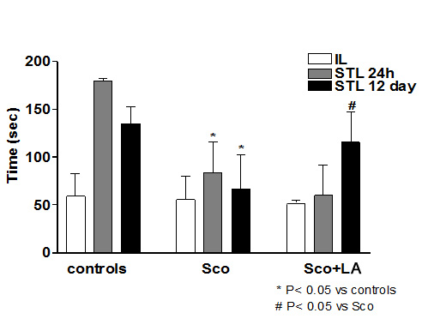
Fig. 1. Effect of LA (on the 24th hour and 12th day) on learning and memory (step-through latency - STL) in rats with scopolamine model of dementia (mean±SEM).
LA administration demonstrated significant improving effect on the learning and memory of animals treated simultaneously with Sco. STL in the group with combination LA+Sco increased significantly by 42% in comparison to Sco treated group (Fig. 1).
Effects of LA administration on OS markers in brain structures of dement animals
An increase of LP was observed in the brain tissues of Sco-treated animals in comparison to the control rats (Fig. 2). The administration of scopolamine led to elevation of TBARs content in cortex by 14.2%, in hippocampus by 51.6% and in striatum by 31.4%. In cortex, the LA reduced the Sco-induced elevation of TBARs by 16.5% as compared to Sco-group. However, in the others structures striatum and hippocampus the LA did not significantly reduce the Sco-induced elevation of TBARs (Fig. 2).
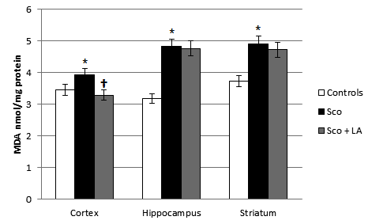
Fig. 2. Effect of LA on lipid peroxidation in brain structures (cortex, hippocampus and striatum) of rats with scopolamine model of dementia (mean±SEM); *p<0.05 vs. control group, †p<0.05 vs. scopolamine group.
In comparison to the control group the treatment of the animals with Sco led to decrease of tGSH level by 4% in the cortex, 26.7% in hippocampus and 22.3% in striatum (Fig. 3). The LA had a positive effect preventing the Sco-induced reduction of tGSH level. In the Sco+LA group the levels of tGSH in all brain structures were similar to those in the control group (Fig. 3).
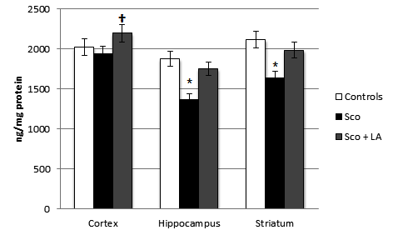
Fig. 3. Effect of LA on total glutathione levels in brain structures (cortex, hippocampus and striatum) of rats with scopolamine model of dementia (mean±SEM); *p<0.05 vs control group, †p<0.05 vs scopolamine group.
In the Sco-group there was a significant activation of antioxidant enzymes in different brain regions: CAT activity was increased by 30.1% in the cortex, 31.3% in hippocampus and 56.3% in striatum (Fig. 4); SOD activity was increased by 73.6% in the cortex, 62.0% in hippocampus and 90.6% in striatum (Fig. 5); GPx activity was increased by 5.3% in the cortex, 6.0% in hippocampus and 8.9% in striatum (Fig. 6) compared to healthy control.
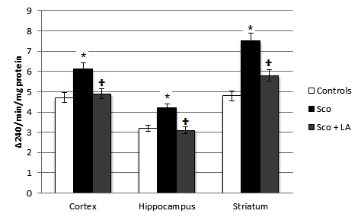
Fig. 4. Effect of LA on CAT activities in different brain structures in rats with scopolamine model of dementia (mean±SEM);*p<0.05 vs control group, †p<0.05 vs scopolamine group.
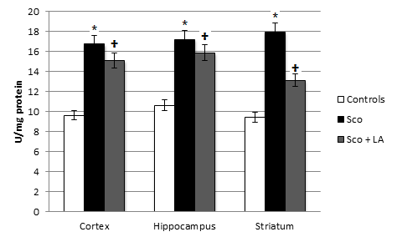
Fig. 5. Effect of LA on SOD activities in different brain structures in rats with scopolamine model of dementia (mean±SEM);*p<0.05 vs control group, †p<0.05 vs scopolamine group.
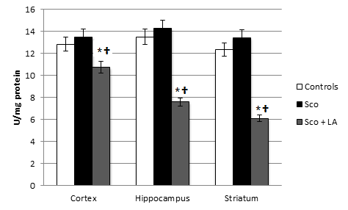
Fig. 6. Effect of LA on GPx activities in different brain structures in rats with scopolamine model of dementia (mean±SEM); *p<0.05 vs control group, †p<0.05 vs scopolamine group.
From the detected increase of antioxidant enzymes’ activities, that of the GPx was the lowest, less than 10%. The LA administration jointly with Sco restored the CAT activities and slightly decreased the Sco-induced increase of SOD activities. The GPx activities were strongly inhibited in the Sco+LA group.
DISCUSSION
It is believed that oxidative stress is a critical factor in AD and scopolamine treatment of animals increases oxidative stress in the whole brain, as well as in the brain structures associated with memory and learning [23]. In our study Sco-treatment of rats significantly increased TBARs concentration and decreased tGSH level. Our data confirmed the ability of scopolamine to produce similar to AD type dementia accompanied by oxidative stress. This effect was established by many other studies in the literature [24-27]. In the present study we also observed an increase in antioxidant enzyme activities after Sco treatment of the rats. Similar to our findings El-Sherbiny et al. [26] observed an increase in brain GPx activity in rats after acute administration of scopolamine (1.4 mg/kg, i.p.). Literature data related to antioxidant enzyme activities after animal treatment with scopolamine are controversial. Nade et al. [28] found a decrease in SOD activity after injection of young mice (8 weeks age) with Sco (1 mg/kg, i.p.). Budzynska et al. [24] noticed a significant decrease in GPx activities in whole brain, prefrontal cortex and hippocampus, as well as a significant decrease in both glutathione reductase and SOD activities in prefrontal cortex and hippocampus in scopolamine treated mice (1 mg/kg, i.p.) in comparison to saline-treated group. The research of Tabari et al. [29] showed little changes in brain SOD and GPx in tissue in animals which had received scopolamine. The differences in obtained data may be due to differences in experimental design rather than to the difference in animals’ species used. In regard to our results, it could be assumed that the activation of antioxidant enzymes in response to Sco-induced OS is a cellular protective mechanism. It has been found that the chronic stress induces an increase in oxidative enzyme (Mg-SOD, Cu,Zn-SOD, and CAT) activities in rat hippocampus [30]. The negligible activation of GPx, detected in our study, is probably related to the reduction of the tGSH that is a substrate for the enzyme.
Our results showed that the coadministration of LA with Sco led to a decrease of Sco-induced OS, demonstrated in decreased LPO, increased GSH and restored levels of antioxidant enzymes SOD and CAT to the baseline values. Moreover, an improvement in the learning and memory processes was established after 11 days of administration of LA despite the simultaneous administration of Sco. Although these results could not provide clear understanding of the mechanism of action of the LA, it could be hypothesized that the antioxidant properties of LA are able to affect positively the impaired brain cognitive functions. It has been suggested that nutritional LA does not act as a direct antioxidant, but it stimulates important stress response pathways in cell affecting endogenous cellular antioxidant levels and diminishing the pro-inflammatory processes [31]. Regardless of whether LA acts directly or indirectly, it has been demonstrated that the administration of 600 mg of LA/daily along with the standard treatment with choline-esterase inhibitors to patients with AD for a period of 12 months led to a stabilization of cognitive functions [32]. The extended study up to 48 months showed lower progression of the disease in patients with additive LA supplementation compared to patients with standard therapy [33].
Therefore, our results, in agreement with some literature data, indicate a significant protective effect of LA on brain structures against scopolamine-induced memory impairment and oxidative damage. In conclusion, our study suggests that LA as a powerful antioxidant may provide a successful approach in prophylactics and therapy of AD.
REFERENCES
- W.R. Markesbery, Free Radic. Biol. Med.,23(1), 134 (1997).
- S. Varadarajan, S. Yatin, M. Aksenova, D. A. Butterfield, J. Struct. Biol., 130(2-3), 184 (2000).
- S. Bennett, M. M. Grant. S. Aldred, J Alzheimers Dis., 17(2), 245 (2009).
- E.E. Devore, F. Grodstein, F.J. VanRooij, A. Hofman, M.J. Stampfer J.C. Witteman M.M. Breteler, Arch. Neurol., 67(7), 819 (2010).
- M.J. Engelhart, M.I. Geerlings, A. Ruitenberg, J.C. Van Swieten, A. Hofman, J.C. Witteman, M.M. Breteler. JAMA, 287(24), 3223 (2002).
- L. Packer, E.H. Witt, H.J. Tritschler, Free Radic. Biol. Med., 19(2), 227 (1995).
- Y.F. Ali, S.O. Desouky, N.S. Selim, Kh.M. Ereiba, Journal of Radiation Research and Applied Sciences, 8, 26 (2015).
- N. Ambrosi, V. Arrosagaray, D. Guerrieri, P.D. Uva J. Petroni, M.B. Herrera, J. L. Iovanna, L.León, C. Incardona, H.E.Chuluyan, D.H. Casadei, Transplantation, 4, 908 (2016).
- U. Singh, I. Jialal, Nutrition Reviews, 66(11), 646 (2008).
- E. Kan, E. Kiliçkan, A. Ayar, R. Çolak, Int. Ophthalmol., 35(1), 115 (2014).
- K. Steliou, D.V. Faller, C.A. Pinkert, M.H. Irwin, W.H. Moos, Drug Dev. Res., 76(4), 167 (2015).
- D.W. Li, G.R Li, Y. Lu, Z.Q. Liu, M.Chang, M.Yao, W.Cheng, L.S.Hu. Int. J. Mol.Med., 32(1), 108 (2013).
- P. Arivazhagan, T. Thilakavathy, K. Ramanathan, S. Kumaran, C. Panneerselvam, Journal of Nutritional Biochemistry, 13 (10), 619 (2002).
- M.E. Jarvik, R. Kopp, Psychol. Rep., 21, 221 (1967).
- L. Valzelli, S. Garattini, J. Neurochem., 15, 259 (1968).
- O.H. Lowry, N.J. Rosenbrough, A.L. Farr, R.J. Randal, J. Biol. Chem., 193, 265 (1951).
- F. Hunter, J. Gebinski, P. Hoffstein, J. Weinstein, A. Scott, J. Biol. Chem., 238, 828 (1963).
- F. Tietze, Anal Biochem., 27(3), 502 (1969).
- H. Aebi, Methods Enzymol., 105, 121 (1984).
- C. Beauchamp, I. Fridovich, Anal. Biochem., 44(1), 276 (1971).
- W.A. Günzler, H. Vergin, I. Müller, L. Flohé, Hoppe-Seyler’s Zeitschrift für Physiol. Chemie, 353(6), 1001 (1972).
- D. Pachauri, S. Tota, K. Khandelwal, P.R. Verma, C. Nath, K. Hanif, R. Shukla, J.K. Saxena, A.K. Dwivedi, J. Ethnopharmacol.,139, 34(2012).
- D.G. Smith, R. Cappai, K.J. Barnham, Biochim. Biophys. Acta, 768, 1976 (2007).
- B. Budzynska, A. Boguszewska-Czubara, M. Kruk-Slomka, K. Skalicka-Wozniak, A. Michalak, I. Musik, G. Biala, Psychopharmacology, 232, 931 (2015).
- M.F. El-Khadragy, E.M. Al-Olayan, A.E. Abdel Moneim, CNS Neurol. Disord. Drug Targets, 13(4), 684 (2014).
- D.A. El-Sherbiny, A.E. Khalifa, A.S. Attia, E.D. Eldenshary, Pharmacol. Biochem. Behav., 76, 525 (2003).
- H. F. Zaki, A. May. A. E. Fattah, S. Amina, Bulletin of Faculty of Pharmacy, Cairo University, 52, 15 (2014).
- V.S. Nade, S.V. Kanhere, L.A. Kawale, A.V.Yadav, Indian J. Pharmacology, 43(2), 137 (2011).
- S. S. Tabari, S. Babri, F.Mirzaie, F.Farajdokht, G.Mohaddes, Acta Cir. Bras.,31 (8), 520 (2016).
- V. Stojiljković, A. Todorović, J. Kasapović, S. Pejić, S.B. Pajović, Ann. N. Y. Acad. Sci.,1048, 373 (2005).
- S.K.P. Shay, R.F. Moreau, E.J. Smith, T.M. Hagen, UBMB Life, 60(6), 362 (2008).
- K. Hager, M. Kenklies, J. McAfoose, J. Engel, G. Münch, J. Neural. Transm. Suppl., 72, 189 (2007).
- K. Hager, A. Marahrens, M. Kenklies, P. Riederer, G. Münch, Erratum in Arch. Gerontol. Geriatr., 51(1), 110 (2010).

АНТИОКСИДАНТНИ МЕХАНИЗМИ НА НЕВРОПРОТЕКТИВНИЯ ЕФЕКТ НА ЛИПОЕВА КИСЕЛИНА ВЪРХУ ОБУЧЕНИЕТО И ПАМЕТТА НА ПЛЪХОВЕ С ЕКСПЕРИМЕНТАЛНО ПРЕДИЗВИКАНА ДЕМЕНЦИЯ
E. Р. Цветанова¹, A.П. Георгиева¹, A.В. Александрова^{1*}, Л.Танчева¹, M. И. Лазарова¹, С. T. Драгоманова¹, Л.Г. Алова¹, M. O. Стефанова¹, Р E. Калфин¹
¹ Институт по невробиология, Българска академия на науките, ул. Акад. Г. Бончев 23, 1113 София, България
² Катедра по фармакология, токсикология и фармакотерапия, Медицински университет „Проф. Парашкев Стоянов”, ул. Марин Дринов 55, 9002 Варна, България
Постъпила на коригирана на
(Резюме)
Болестта на Алцхаймер (AD) е една от най-често срещаните форми на деменция, която засяга около 36 милиона души и няма ефективно лечение. Оксидативният стрес е една от предполагаемите причини за механизма на действие на AD. Възможните превантивни ефекти на някои антиоксиданти продължават да са предмет на клинични и експериментални изследвания. Целта на това изследване е да се оцени антиоксидантният механизъм на невропротективния ефект на липоевата киселина (LA) върху когнитивните функции при експериментално предизвикана деменция. Деменция от Алцхаймеров тип е предизвикана чрез прилагане на скополамин (Sco, 1 mg/kg интраперитонеално, i.p.) на мъжки Wistar плъхове в продължение на 11 дни. Липоева киселина (LA, 30 mg/kg i.p.) е прилагана през същия период. Обучението и паметта на плъховете са оценени с помощта на пасивен тест за обучение за избягване на неприятни ситуации (Step through test). На 24-ия час след последното прилагане фронталната мозъчна кора, хипокампусът и стриатумът са изолирани и хомогенизирани. Хомогенатите са използвани за определяне на малонов диалдехид (MDA), общ глутатион (tGSH) и активностите на супероксид дисмутазата (SOD), глутатион пероксидазата и каталазата (CAT). Моделът на деменцията е проверен с помощта на когнитивни тестове. В мозъчните структури на Sco-групата MDA се повишава, tGSH се понижава и се наблюдават активирани антиоксидантни ензими. LA значително подобрява когнитивните функции и оксидативния статус, влошени от Sco, чрез повишеното ниво на tGSH, възстановените CAT и SOD активности. По този начин LA значително подобрява влошената памет на животни с деменция посредством антиоксидантния си капацитет и би могла да се използва за превенция и терапия на AD.

