A new study on the derivatization of malondialdehyde by anisidine reagent with use of UV-Vis, FT-IR, and NMR techniques

B. Akbari¹, M.E.Olya²*, M. Bahmaei¹, F. Najafi³
¹Department of Chemistry, Tehran North Branch, Islamic Azad University, Tehran, Iran
²Environmental research Department, Institute for color science and technology, Tehran, Iran
³Department of Resin and Additives, Institute for Color Science and Technology, Tehran, Iran
Received June 26, 2015, Revised September 10, 2015
Derivative methods of malondialdehyde (MDA) as a biomarker of oxidative stress often require high temperature and long heating time. Some of which activate a color reaction such as thiobarbituric acid reactive substances (TBA), Diaminonaphtalene, Pentafluorophenyl hydrazine, and Phenylhydrazine after placing in that harsh condition. Our attempts were to introduce a new derivative reaction between malondialdehyde and Para methoxy aniline (PMA) to identify MDA. The derivatization of malondialdehyde (MDA) with different concentration of para-methoxy aniline (Anisidine) in an acidic medium and various time, temperature, and pH was investigated. The possible reaction of malondialdehyde and Anisidine was completed after 10 min at 75^{oC} in optimal condition. By spectrophotometric techniques, the complex formed in this process exhibits a highly specific UV spectrum with a sharp maximum at 400nm. (¹H and ¹³C) NMR, and FT-IR were confirmed the formed adduct.

Keywords: Malondialdehyde, Anisidine, colorimetric reaction, derivatization

1. INTRODUCTION
To whom all correspondence should be sent:
© 2016 Bulgarian Academy of Sciences, Union of Chemists in Bulgaria
E-mail: Olya-me@icrc.ac.ir
Malondialdehyde (MDA), as one of the great significance individual aldehyde resulting from lipid peroxidation, is a reactive unsaturated dicarbonyl that can easily bind to macromolecules such as structural and functional proteins and nucleic acids (Karatas et al., 2002; Grotto et al., 2007; Del Rio et al., 2005; Agarwal et al.,2007; Seljeskog et al., 2006). As of now, the great number of analytical approaches for determination of Malondialdehyde (MDA) with various derivative methods have been proposed. Most procedures based on the aldehydic reactivity of MDA employed hydrazine-based derivatization reagents (Giera et al.,2012; Grintzalis et al., 2013). Still, the classical assay "2-thiobarbituric acid (TBA) is the most general applied technology in which two molecules of TBA change with one molecule of MDA to give a colored reaction product which can be measured spectrophotometrically at 535 nm, or by fluorescence detection with excitation at 530 nm and emission at 550 nm(Steghens et al., 2001; Czauderna et al., 2011; Mendes et al., 2009; Pilz et al., 2000; Shibamoto et al., 2006). In fact, the TBA assay is a non-specific method for MDA; therefore, further developed methods were strongly suggested by researchers with the use of new color reagent for detection of this prominent biomarker. Sim et al., 2003; Khoubnasabjafari et al., 2015; Shahidi, F. et al., 2005). Derivative reagents, namely, thiobarbituricacid, diamino-naphtalene (DNPH), Pentafluorophenylhydrazine (PFH), Phenylhydrazine (PH), dansylhydrazine, methylhydrazine, 2,2,2-Trifluoroethylhydrazine and FMOC-hydrazine after placing in high temperature, and longtime have been proposed by researchers to measure MDA through expensive separation technology such as reverse phase-liquid chromatography (RP-HPLC), gas chromatography–mass spectrometry (GC-MS), and liquid chromatography–mass spectrometry (LC-MS, or alternatively HPLC-MS) (Giera et al.,2012). However, the result of their investigations was unsatisfactory.
On the other hand, para-anisidine (p-anisidine) value would be a well-known method to measure the content of aldehydes (principally 2 alkenals and 2, 4-alkadienals) generated during the decomposition of hyroperoxides. para-methoxyaniline (anisidine or PMA) and the aldehydic compounds under acidic conditions provide yellowish products and absorb at 350 nm (Aruoma et al.,1998). Besides, p-An Value is a valid indicator of oxidative rancidity in oils and fatty foods (Mao et al., 2006; Shibamoto et al.,2006). However, no specific method has been developed for determination of malondialdehyde by anisidine reagent.
In this paper, based on colorimetric reaction, a new method for synthesis and identification of MDA was introduced. Investigation of complex formation (MDA-PMA) with the use of variegated techniques was studied as well. In addition, it was expected that this procedure would assure a simple, selective, and sensitive measurement of MDA for further biological studies.
© 2016 Bulgarian Academy of Sciences, Union of Chemists in Bulgaria
2. EXPERIMENTAL

2.1. Material and methods
Malondialdehyde Tetra butyl ammonium salt (MDA, 96%) was purchased from Sigma Aldrich. In addition, para methoxy aniline, butylatedhydroxytoluene, glacial acid acetic, HClO₄ 0.1 M diluted in glacial acetic acid, absolute ethanol, and sodium hydroxides were from Merck Company.

2.2. Solvent selection
To find an appropriate solvent, a possible reaction between Malondialdehyde Tetra butyl ammonium salt (MDA, 96%) and para-methoxy aniline (anisidine, PMA) was evaluated. Therefore, different solvents such as HPLC-grade water, absolute ethanol, glacial acid acetic, and HCl were examined. Finally, absolute ethanol and glacial acetic acid were selected as two proper solvents for MDA and Para methoxy aniline, respectively.

2.3. Preparation of Anisidine reagent
p-methoxy aniline (Anisidine) as a reagent was prepared at 1000 µM.L⁻¹(µM = µM.L⁻¹ =n mol/ ml) in glacial acetic acid, by dissolving 0.0123 g of ansidine in 100 ml of glacial acetic acid. The solution was protected from the light and was stored at room temperature for a daily basis. The maximum absorbance was at 273 nm (Figure.1).

Fig. 1. Wavelength of Anisidine diluted in glacial acetic acid

Anisidine was fully tested on room temperature in the dark place with two different concentrations (500 and 1000 µM) to investigate its stability in long period. Anisidine stability had a constant trend within 30 days.

2.4. Preparation of MDA stock solution
Standard stock solution of MDA (5000 µM.L⁻¹) was obtained by dissolving 0.0156 g of Malondialdehyde Tetra butyl ammonium salt in 10ml of absolute ethanol. (Figure.2). This stock solution remained stable for at least 6 months, and stored at -20 ^{oC} in aliquots of 250 µl in dark place while the working standard solutions had to be prepared every day MDA solution was monitored by its absorbance at 267nm (Giera et al.,2012).

2.5. The process of derivatisation
First, seven clean glass test tubes were taken and labeled them (A-G). Second, different concentrations of MDA standard stock solutions were prepared (50, 25, 10.5, 5, 2.5, 1, and 0.5 μM) and diluted by absolute ethanol. Afterwards, two ml of prepared MDA solution was transferred to each labeled glass tubes. Then, two ml of Anisidine (500 μM) as a color reagent was added to them and vortex the solution. Finally, the tubes were closed and placed them to any holder to keep the tubes upright during boiling at 90 ^{oC}. After 10 min, immediately, the tubes were removed and were placed in ice bath to stop the reaction. At least, 15 min was needed to be cooled down. Without any extraction steps, two ml of the clear yellowish complex of each glass tubes were loaded to absorption cell for reading the absorbance at 400-404 nm by UV-Vis.

Fig. 2. Wavelength of malondialdhyde tetrabutyl ammonium salt diluted in absolute ethanol.

2.5. The process of derivatisation
First, seven clean glass test tubes were taken and labeled them (A-G). Second, different concentrations of MDA standard stock solutions were prepared (50, 25, 10.5, 5, 2.5, 1, and 0.5 μM) and diluted by absolute ethanol. Afterwards, two ml of prepared MDA solution was transferred to each labeled glass tubes. Then, two ml of Anisidine (500 μM) as a color reagent was added to them and vortex the solution. Finally, the tubes were closed and placed them to any holder to keep the tubes upright during boiling at 90 ^{oC}. After 10 min, immediately, the tubes were removed and were placed in ice bath to stop the reaction. At least, 15 min was needed to be cooled down. Without any extraction steps, two ml of the clear yellowish complex of each glass tubes were loaded to absorption cell for reading the absorbance at 400-404 nm by UV-Vis.
2.6. Investigation of concentration, time, and temperature
Various concentrations of MDA standards (50, 12.5, 3.125 µM.L⁻¹) and Anisidine reagent (30, 50, 100, 150, 250, 500 µM.L⁻¹) were prepared by further dilution of their stock solutions. After preparing anisidine reagent in glacial acetic acid, the solution should be protected from the light within the procedure. For activating the color, derivatization was performed at different reaction times (5, 10, 20, 30, and 40 min) and at different temperature (30, 70, and 90 ^{oC}) to evaluate the optimum conditions of MDA derivatization.

2.7. Process of complex (MDA-PMA) formation
Appropriate volumes and concentrations of anisidine, optimum temperature, and time were the significant parameters that needed to be studied. In fact, to explore the colorimetric reaction between MDA and PMA, several tests with various concentrations of each have been done. Briefly, by our research work, various concentrations of MDA standards (50, 12.5, 3.125 µM) and anisidine reagent (150, 250, 500 µM) were prepared by further dilution of the stock solutions. Afterwards, two milliliter of prepared MDA solution (50) was transferred to a labeled glass tube (Complex MDA-PMA).Then, two ml of Anisidine (500 μM) as a color reagent was added to the labeled tube (Complex MDA-PMA) and vortex the solution. Finally, the tube was closed and placed them to any holder to keep the tubes upright during boiling at 90, 70, and 30 ^{oC} . After 10 min, immediately, the tubes were removed and placed in ice bath to stop reaction. At least, 10 min was needed to be cooled down. The optimum condition provided for stable yellowish color adduct (complex A) was considered as follows: (Time: 20 min, Temperature 75 ^{oC} , Anisidine concentration 500 µM).

2.8. Synthesis of MDA-PMA adduct
The product (MDA-PMA) is not commercially available, but it can be prepared in laboratory condition. Formation of imine compound was necessary to evaluate the reaction and confirmation of MDA-PMA adduct. The derivatisation procedure is based on the principle of (0.5g) of MDA reacting with (0.4g) of anisidine prepared with glacial acetic acid at room temperature.
It was found that an imine compound is produced after a few seconds. Then, yellow-orange product was dried at 60 ^{oC} for 4 h in a vacuum drying oven. The structure of this compound was confirmed by different methods namely NMR (¹H and ¹³C), and FT-IR.

2.9. Effect of pH
The pH effect of the derivatization reaction on the MDA value was investigated by previous scientists [3]. Although this new procedure was confirmed at pH= 7.4, the validity of the derivative method has been questioned in various pH (acidic or basic medium). In other words, the complete reaction should be evaluated in different pH for the future biological studies. For this reason, the pH ranges (3, 7, and 12.0) have been selected.
In normal pH (p H= 7.4), two ml of MDA (50 µM) was added to two ml of Anisidine (500µM) in a 10 ml lab tube. Then, this reaction mixture was placed in the water bath for 10 min at 90 ^{oC}. The solution was cooled and ready for the analysis by UV-Vis spectrophotometer at 400-404nm.
In the basic medium, 200 µl of 6 M NaOH was added to 1000 µl of MDA in a 10ml lab tube. By placing this mixture at 60 ^{oC} in the water bath for 30 min, allow medium to be basic. After cooling, 200 µl of Anisidine reagent (500µM) was added to this basic solution. The same as above, the reaction mixture was placed in water bath for 10 min at 90 ^{oC}. The solution was cooled and ready for the analysis by UV-Vis spectrophotometer at 400-404nm.
In the acidic medium, 250 µl of HClO₄ (0.1 M) diluted in glacial acetic acid was added to 1000 µl of MDA (50 µM) in a 10ml lab tube and vortex. Then, 200 µl of Anisidine reagent (500µM) was added to the tube and finally, this mixture was placed in water bath for10 min at 90 ^{oC}. The solution was cooled and ready for the analysis by spectrophotometer at 400 nm.

2.10. Techniques
Possible structure of the formed adduct (complex MDA-PMA) under above condition was confirmed by UV-Vis spectrophotometry, FT-IR, and NMR techniques.
2.10.1. Spectrophotometric analysis. After cooling in icy bath to stop the reaction, without any extraction steps, the solution was analyzed by spectrophotometer using a Lambda Bio 20 spectrometer (Perkin-Elmer, Rotkreuz, Switzerland) using 1-cm absorption cell. Spectrum of MDA-PMA solutions was recorded from 200 to 600 nm at a scanning speed of one nm/min against of the glacial acetic acid as a blank reaction mixture. Absorbance reading was done at 404nm. Data acquisition and processing were carried out with the Perkin-Elmer UV Winlab software.

2.10.2. FT-IR analysis. The infrared (IR) spectra of the samples were recorded in the range 400–4000 cm⁻¹ on a Fourier transform infrared (FTIR) spectrometer (model Perkin-Elmer, Rotkreuz, Switzerland) using KBr pellet method.
2.10.3. Nuclear magnetic resonance spectroscopy. NMR spectra were performed on a 250 MHz Brüker (Germany) in deuterated chloroform for both experiments at room temperature to find whether the imine was formed or not.

3. RESULTS AND DISCUSSION

3.1. Influence of time in derivative reaction
The yellow complex under 30 ºC cannot be produced, although time and concentration of Anisidine equal to 500 μM have been raised. However, at 90 and 75^{oC}, reaction accelerates in short time (10min); this vital point can help us to consider the reaction of Imine formation or the same yellow complex in the real biological samples to determine MDA.
According to Figure.3, the temperature of 75 ^{oC} indicates the complete derivatization and the formation of the colorimetric reaction. Moreover, at 90^{oC}, the reaction was carried out in a short time. However, at high level of temperature, the aldehyde levels may be raised in the real samples from the actual results which make it difficult to evaluate the data (Seljeskog et al.,2006). Therefore, to implement this method in biological samples, using 75 ^{oC} as an optimal temperature can be suited for the analysis. Furthermore, to obtain complete derivative reaction with Anisidine (500µM) at 75 ^{oC}, 20 min would be a proper time. Actually, by using 250 µM or lower concentrations of Anisidine, the complex (MDA-PMA) was remained at an intermediate state and the yellowish complex will not be formed and its result will not be suitable for the real samples. Therefore, the reaction is completed by Anisidine (500 μM) with optimized temperature at 75 ^{oC} within 20 min. (Figure 4.1 and Figure 4.2)

Fig. 3. Formation of yellow complex at different temperature (30,75, 90 ^{oC})

Fig.4.1. The relationship between different anisidine concentration and time in complex (MDA-PMA) formation at 30 ^{oC}

Fig. 4.2 The relationship between different anisidine concentration and time in complex (MDA-PMA) formation at 75 ^{0C}

On the other hand, TFEH, and PFH as derivative reagents require harsh temperature to produce complex (Giera et al.,2012 ). Temperature effect on derivative procedure was considered as an important part in this research; therefore, the samples placed in a water bath at 30, 75 and 90 ^{oC} and room temperature, then, cooled in icy bath.
To evaluate the optimum condition for formation of the complex [MDA-PMA], different concentrations of Anisidine (30, 50, 100, 150, 250, 500 µM) was added to different concentrations of MDA (3.125, 12.5 and 50 μM) in different times (5, 10, 20, 30 and 40) and in separate runs.
The results of Fig.4.1 indicate that yellow adduct was not formed at 30 ^{oC} and room temperature. Optimal temperature and time as the main part of derivation process were considered in this study. Under low temperature (30 ^{oC}), the reaction was slow and proceeded to produce an intermediate compound. Even, by increasing in the molar concentration of anisidine and time, it produces higher concentration of intermediate

compounds; this indicates that derivative adduct could not be formed in this concentration and temperature. However, while the concentration of Anisidine is 10 times higher than MDA concentration, the yellow color reduces the form of intermediate compounds and enhances the form of complex.
It seems that the procedure was completed at 90 ^{oC} in 10 min which contribute to form the imine reaction or yellow adduct in this temperature while this should be considered that high temperature is not proper for this procedure due to evaporation of malondialdehyde and solvents during derivative process. So this may be difficult to maintain the derivative concentrations.
On the other hand, at 30ºC, there is no yellowish complex; therefore, it is not a proper temperature to assess the complex formation. Nevertheless, at 75ºC, the reaction was completed in 40 min and the concentration of anisidine selected at 500 μm while Mao’s method reaction time was 3 hours with FMOC reagent (Mao et al., 2006).
As can be seen in Figure 5, at the wavelength of 300-380 nm, the wide peak is related to intermediate formation whereas in Figure 6, relatively high peak in the range of 400-404 nm indicates reduced concentration of intermediate and formation of adduct (or the same considered complex).

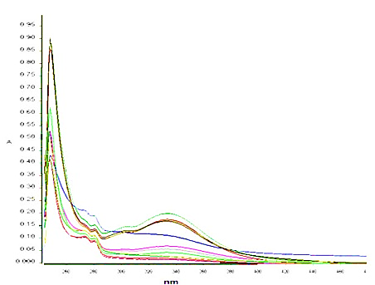

Fig.5. Different concentration of anisidine with their absorbance spectra of derivative complex at 30 ^{oC} in complete reaction (Complete reaction)

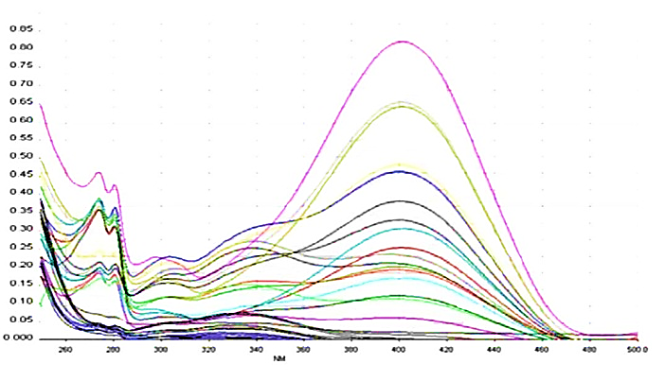

Fig.6. Different concentration of anisidine with their absorbance spectra of derivative complex at 90 ^{oC} in complete reaction (Complete reaction)

The colorant has a strong absorbance peak in the visible range in 400 nm related to electronic transference π→ π* (Figure.6). The absorbance peaks in UV region are related to electron transference of benzene rings (Mendes et al., 2009). The obtained peak in visible range in the range of 300 to 395 is related to the formation of intermediates and the peak value decreases by high temperature. Likewise, by altering anisidine concentration, the adduct peak value increases.

3.2. Optimal condition for derivative procedure
The reaction of Anisidine (para - methoxy aniline) with aldehydic groups can be considered as an addition reaction. The yellowish complex emerged from releasing H₂O molecules present a stable adduct. Investigating the reaction depended on MDA concentration indicated that the more molar concentration of anisidine, the more increase in the concentration of yellow complex (MDA-PMA). Derivatized adduct was evaluated with the molar ratios of 1/2:1 to 1:10 (MDA: Anisidine). Figure.4.2 depicts when the molar ratio of anisidine concentration is (10[MDA]), the derivative solution attains to a higher level; thus, the derivatization was completed at the molar ratio of 10:1.
3.3. Stability
Current method is significantly different from Mao J, Zhang H, et al. (Mao et al., 2006). Their method was time consuming procedure (4 hour) at 50 ^{oC} to reach near completion reaction (Mao et al., 2006). To prevent false results, stability of malondialdehyde and anisidine as a crucial methodological aspect of this study were evaluated by UV-Vis spectrophotometry.
The absorbance reading of PMA (1000 µM and 500 µM) and MDA (stock solution (5000 µM) and its working standard solution (50 µM)) was done at 273 nm and 267 nm, respectively. It is clearly observed in Figure.7.1 that the solution of PMA was stable if it is protected from light. Nevertheless, it would be better to prepare 500 µM concentration of PMA at the time of the test. Figure.7.2 depicts the satisfactory results of 5000 µM concentration of MDA stock solution in terms of stability. However, working standard solution did not prove to be stable over 30-days period. Thus, it is only possible to use stock solution to prepare working standard solution at the time of test because MDA becomes degradation less than 24 hour.
On the other hand, FMOC-hydrazine and DNPH (as derivative reagents) increased the derivative reaction under mild acidic conditions and lower temperatures, because of having identical hydrazine groups, which are strong nucleophiles and can readily react with aldehydes. These conditions prevent undesired artificial aldehyde formation generated during the sample pretreatment. The derivative reagents such as DNPH need several Liquid-Liquid extractions due to the excess of unreached DNPH. Therefore, separation of the MDA-DNPH will be difficult and because of DNPH instability, purification of DNPH should be performed on a daily basis (Mao et al., 2006; Shibamoto et al.,2006).
Consequently, based on above aforementioned results, this method did not require multiple extraction steps for anisidine reagent and thus, no residue or cloudiness was appeared during and after derivative procedure, which made this procedure preferable over the other methods. Furthermore, the yellowish adduct has no hazardous material if keep it for a long time in a laboratory. A feature which is crucial in developing a precise and accurate quantitative method is the stability of PMA. FMOC-Hydrazone (as a reagent) is only stable for 72 h at room temperature whereas PMA is stable for at least 1 month at room temperature if it is protected from light (Mao et al., 2006; Shibamoto et al.,2006).

Fig.7.1. Evaluation of PMA stability

Fig.7.2. Evaluation of MDA stability

3.4. The effect of pH
The influence of pH in this procedure was examined. As can be seen in Figure 8, derivative complex at different pH (3.0, 7.4, 12.2) was formed after 10 min at 90 ^{oC}. The maximum yield was achieved at 400 nm in each pH. The results may contribute to apply this procedure for determination of free and total MDA in biological samples at different pH for further studies.

Fig.8. Evaluation of different pH for complex formation

3.5. Mechanism of imine formation
The formation of the imine is the initial step in this reaction. The imine was formed after reacting an amine (1⁰) with aldehydes to form a dipolar intermediate. The reaction has two steps:
1-NH₂ preferentially approach to carbonyl groups of aldehydes 2- Elimination of water group.
In the current study, imine formed during the synthesis procedure identified by NMR and FT-IR techniques was confirmed as the adduct. The possible mechanism of MDA derivatization was depicted in Figure.9.
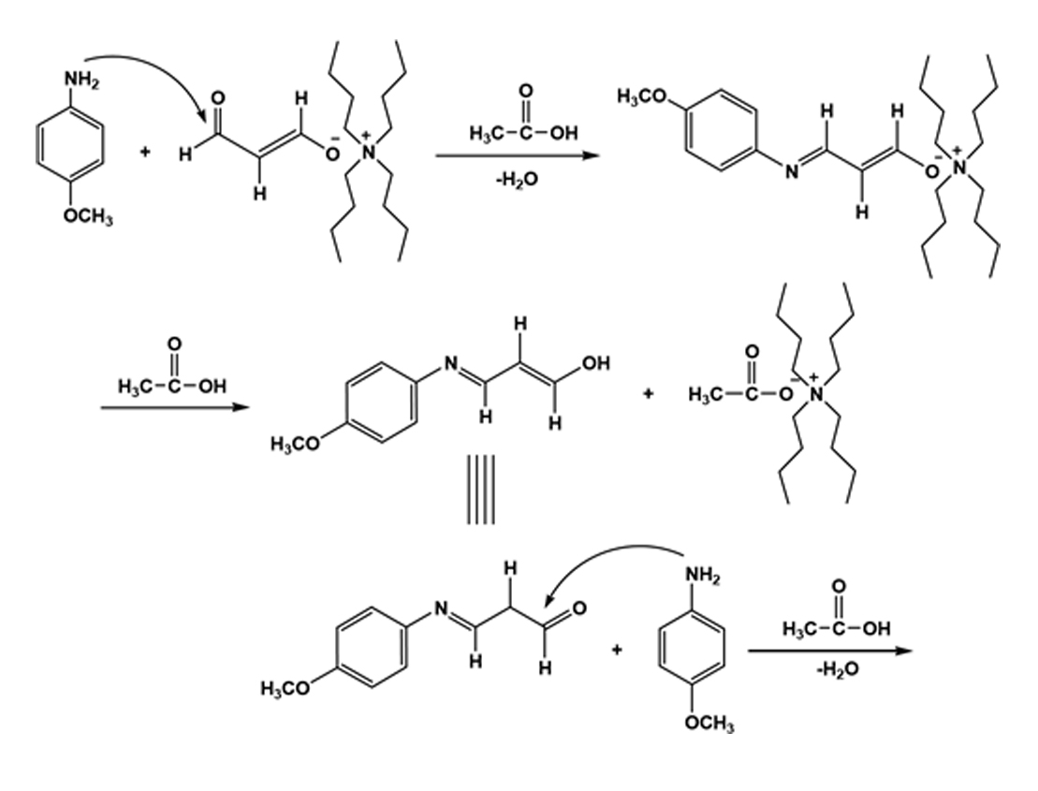
N
H
3
CO
H
H
H
N
OCH
3
N
OCH
3
H
H
N
H
3
CO
H
H
H

Fig.9.The mechanism of MDA-PMA adduct

3.6. The results of UV-Vis, FT-IR, and NMR

3.6.1. Spectrophotometric results
MDA and other carbonyl compounds naturally exist as byproducts of lipid peroxidation and prostaglandin biosynthesis. With regard to analytical approaches, it is better to derivatize MDA with reagents having high molar absorptivity at longer UV wavelengths (>254 nm). In fact, the high molar absorptivity and the close proximity of the absorbance maximum to ~ 300nm make an MDA derivative almost preferably suited for detection using a diode array system (Czauderna et al., 2011). (Figure.10)
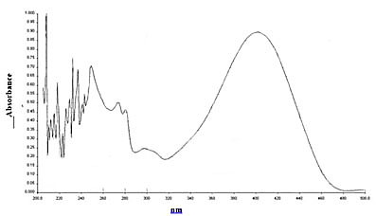
Fig.10. Spectrum of yellow adduct at 75⁰C (50 µM MDA- 500 µM PMA)

3.6.2. FT-IR results
The FT-IR spectrums of MDA-derivatisation, primary Anisidine and malondialdehyde were confirmed in the reaction. IR spectra were different from spectra of MDA before and after derivative reaction. The important IR bands of the compounds along with their assignments are given in Figures 11.1, 11.2, and 11.3.

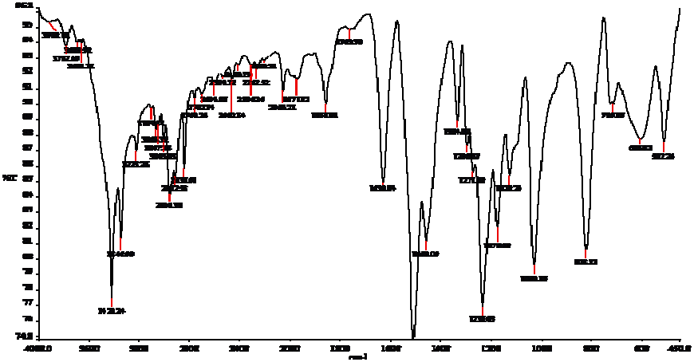

NH₂

OCH₃
Fig.11.1. IR-spectra of Anisidine

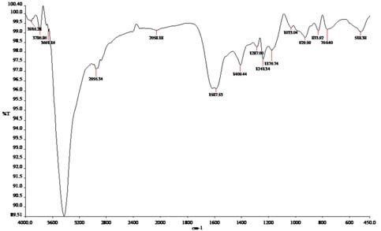
H
O
O
H
H
N

Fig.11.2. IR spectrum of Malondialdehyde tetrabutyl ammonium salt molecule
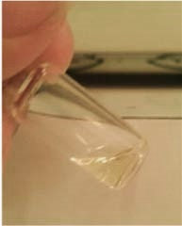
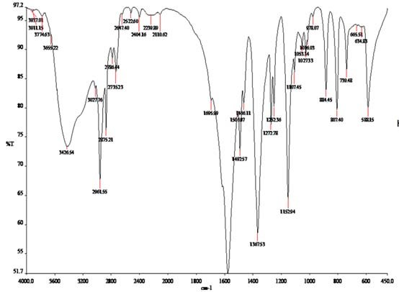

N
H
3
CO
H
H
H
N
OCH
3
N
OCH
3
H
H
N
H
3
CO
H
H
H

Fig.11.3. IR spectrum of MDA-PMA and the proposed synthetic molecule

Analytical data

Important infrared spectral (cm⁻¹) bands of Anisidine
Figure 11.1: IR-spectra of Anisidine demonstrate the N-H tension bond appears close 3346 and 3232cm⁻¹. Another band at 3103 cm⁻¹ was proved the aromatic CH tension. Furthermore, signals between 2838 cm⁻¹ correspondent to the C-H aliphatic. Moreover, Band at 1510 shows the C=C and signals at 1334 and 1459 cm⁻¹ depict the tension band of the CH₃ and N-H, respectively. The stretching vibration of the C-N and C-O band for the methoxy group were appeared at 1235 cm⁻¹ and 1030, respectively.

Important infrared spectral (cm⁻¹) bands of Malondialdhyde

Figure 11.2: IR-spectra of MDA show the C-N stretching band (calculated at 1272 cm⁻¹ ) related to the amine bands. The C-O stretching enol form band is clarified at 1152 cm⁻¹ . The strong peak exhibits the aldehydic form of C=O at 1695 cm⁻¹. The enol form of C=C was verified by the strong band at 1580 cm⁻¹ . Besides, the CH₃ and CH₂ bending at 1367 and 1492 cm ⁻¹ are roughly visible.

IR Spectrum of Adduct

Figure 11.3: IR-spectra of adduct shows Tension signals were eliminated at 2786 and 2735 cm⁻¹ (C-H) due to the reaction between Anisidine and aldehydic group. Further band at 2955 cm⁻¹ appeared as a result of α,β-unsaturated conjugated imides in <2955 cm ⁻¹ .
The new adduct being formed in acetic acid medium is conjugated imine aromatic. Not only is acetic acid as a catalyst for the reaction of amine and MDA but also make tetra-butyle amine separate from MDA and provide possible reaction for MDA and Anisidine again.
The important infrared spectral (cm⁻¹) bands of MDA-PMA are considered in table.1 as follows:

Table.1.

FT-IR results of MDA-PMA Adduct

C-H = 2850 cm⁻¹ N-H (NH group) = 3220 cm⁻¹

C-N (amine group) = 1241 cm⁻¹CH₃ (bending vibration) = 1287cm⁻¹

C-O (enole form) = 1176 cm⁻¹ C=C (α, β unsaturated) = 1587 cm⁻¹

C=N (imide) = 1605 cm⁻¹ N-H = 1409 cm⁻¹

Ammonium ion peak as a byproduct was appeared in a strong state at 3450 cm⁻¹ .This is
the byproduct which has not been fully separated completely. (Figure. 12)

N
H
3
C
C
O
O

Fig.12. The byproduct of MDA-PMA reaction

3.6.3. NMR results
The structure of adduct (MDA-PMA) is confirmed by the ¹H-NMR and ¹³C-NMR. The protons of NH group in CDCL₃ are shown in 9.8 ppm. Figures 13.1, and 13.2.
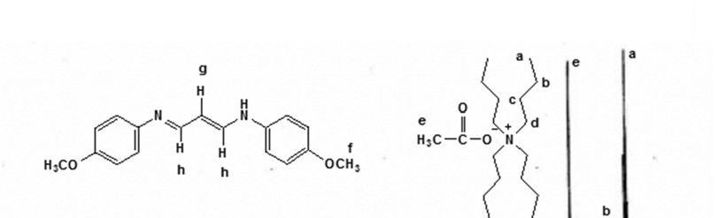
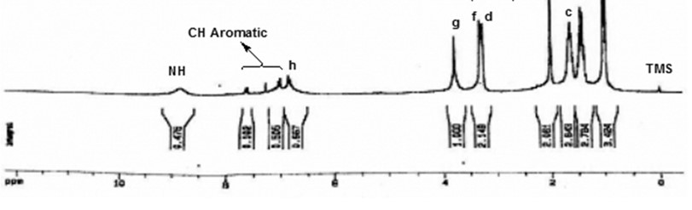

Fig. 10-3: Spectrum of adduct

Fig.13.1.¹H NMR spectra of the adduct (MDA-PMA)
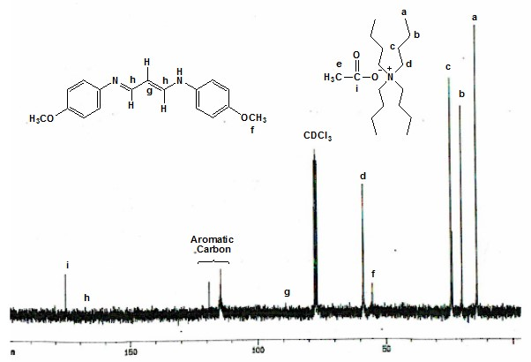

Fig.13.2.¹³C NMR spectra of main production with glacial acid acetic and tetra butyl ammonium salt

Acknowledgements
The authors would like to express their sincere appreciation to Dr. Amirahmadi for her suggestions during this research study.
References
1. Karatas, F., M. Karatepe, and A. Baysar, “Determination of free malondialdehyde in human serum by high-performance liquid chromatography”. Analytical Biochemistry, 2002. 311(1): p. 76-79.
2. Grotto D, Santa Maria LD, Boeira S, Valentini J, Charão MF, Moro AM, Nascimento PC, Pomblum VJ, Garcia SC., “Rapid quantification of malondialdehyde in plasma by high performance liquid chromatography–visible detection”. Journal of Pharmaceutical and Biomedical Analysis, 2007. 43(2): p. 619-624.

3. Del Rio, D., A.J. Stewart, and N. Pellegrini, “A review of recent studies on malondialdehyde as toxic molecule and biological marker of oxidative stress”. Nutrition, metabolism, and cardiovascular diseases: NMCD, 2005. 15(4): p. 316-328.

4. Agarwal, R. and S.D. Chase, “Rapid, fluorimetric–liquid chromatographic determination of malondialdehyde in biological samples”. Journal of Chromatography B, 2002. 775(1): p. 121-126.

5. Seljeskog, E., T. Hervig, and M.A. Mansoor, “A novel HPLC method for the measurement of thiobarbituric acid reactive substances (TBARS). A comparison with a commercially available kit”. Clinical Biochemistry, 2006. 39(9): p. 947-954.

6. Giera, M., H. Lingeman, and W.A. Niessen, “Recent Advancements in the LC- and GC-Based Analysis of Malondialdehyde (MDA): A Brief Overview.” Chromatographia, 2012. 75(9-10): p. 433-440.

7. Grintzalis K, Zisimopoulos D, Grune T, Weber D, Georgiou CD., “Method for the simultaneous determination of free/protein malondialdehyde and lipid/protein hydroperoxides.” Free Radical Biology and Medicine, 2013. 59(0): p. 27-35.

8. Steghens JP1, van Kappel AL, Denis I, Collombel C., “Diaminonaphtalene, a new highly specific regent for HPLC-UV measurement of total and free malondialdehyde in human plasma or serum”. Free Radical Biology and Medicine, 2001. 31(2): p. 242-249.

9. Czauderna, M., J. Kowalczyk, and M. Marounek, “The simple and sensitive measurement of malondialdehyde in selected specimens of biological origin and some feed by reversed phase high performance liquid chromatography”. Journal of Chromatography B, 2011. 879(23): p. 2251-2258.

10. Mendes, R., C. Cardoso, and C. Pestana, “Measurement of malondialdehyde in fish: A comparison study between HPLC methods and the traditional spectrophotometric test.” Food Chemistry, 2009. 112(4): p. 1038-1045.

11. Pilz, J., I. Meineke, and C.H. Gleiter, “Measurement of free and bound malondialdehyde in plasma by high-performance liquid chromatography as the 2,4-dinitrophenylhydrazine derivative. Journal of Chromatography B: Biomedical Sciences and Applications,” 2000. 742(2): p. 315-325.

12. Shibamoto, T., “Analytical methods for trace levels of reactive carbonyl compounds formed in lipid peroxidation systems”. Journal of Pharmaceutical and Biomedical Analysis, 2006. 41(1): p. 12-25.

13. Sim AS, Salonikas C, Naidoo D, Wilcken DE., “Improved method for plasma malondialdehyde measurement by high-performance liquid chromatography using methyl malondialdehyde as an internal standard”. Journal of Chromatography B, 2003. 785(2): p. 337-344.

14. Khoubnasabjafari, M., Ansarin, Kh., and Jouyban, A., "Reliability of malondialdehyde as a biomarker of oxidative stress in psychological disorders." BioImpacts, 2015. 5(3): 123-127.

15. Shahidi, F. and Y. Zhong, “Lipid Oxidation: Measurement Methods”, in Bailey's Industrial Oil and Fat Products, 2005, John Wiley & Sons, Inc., DOI: 10.1002/047167849X.bio050.

16. Aruoma, O., “Free radicals, oxidative stress, and antioxidants in human health and disease”. Journal of the American Oil Chemists' Society, 1998. 75(2): p. 199-212.

17. Mao J, Zhang H, Luo J, Li L, Zhao R, Zhang R, Liu G, “New method for HPLC separation and fluorescence detection of malonaldehyde in normal human plasma." Journal of Chromatography B, 2006. 832(1): 103-108.

