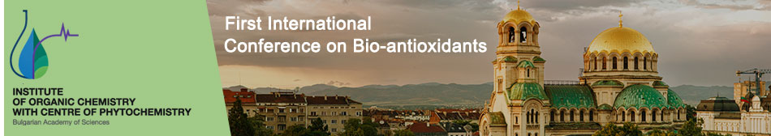

Introduction
Dear Colleagues,
Biologically active compounds with antioxidant potential, i.e., bio-antioxidants (natural and their synthetic analogs) have a wide range of applications. They are important drugs, antibiotics, agrochemical substitutes, food preservatives, etc. Many of the drugs today are synthetic modifications of naturally obtained substances with both biological and antioxidant activities. Nowadays bio-antioxidants play an important role in disease prevention as components of food additives and antioxidant drugs in mono- or in complex therapy.
This special issue C of the Bulgarian Chemical Communications, volume 50, 2018 contains full texts of the oral and poster presentations of the First International Conference on Bio-antioxidants (ICBA 2017) as well as the Young Scientists School on Bio-antioxidants (YSSBA 2017) “Natural bio-antioxidants – as a base for new synthetic drugs and food additives/supplements”. They are separated to the following strategic topics of the conference:

- Oxidative Stress and Human Health
- Natural Bio-antioxidants
- Synthetic Analogues of Natural Bio-antioxidants
- Homogeneous and Heterogeneous Lipid Oxidation
- Food Analysis, Food Additives and Food Supplements
- Advanced Methods for Analysis of Bio-antioxidants

You can find here the papers of the plenary and key lectures of many leading scientist, but also of several young investigators from all over the world (Bulgaria, Russian Federation, Italy, Spain, Poland, Brazil, Austria etc.). Approximately 120 participants and 30 young scientists, students and pupils participated of this prestigious international conference. All papers are closely related and dedicated to the development and application of novel bio-antioxidants for prevention and therapy of clinically and socially important diseases related to the oxidative stress their knowledge, both in scientific and clinical aspect.

Guest editors:
Prof. Dr. Vessela D. KANCHEVA Prof. DSc. Ryszard AMAROWICZ
Institute of Organic Chemistry Institute of Animal Reproduction
with Centre of Phytochemistry and Food Research,
Bulgarian Academy of Scientists, Polish Academy of Sciences
Sofia 1113, Bulgaria Olsztyn10-747, Poland
